Supplemental Materials for

Process and Content in Decisions from Memory

**Results with Different Clustering Solutions**

In the main text, when reporting results regarding the memory models, we used the *k* = 3 *k*-means thought clustering solutions (i.e., seven distinct thought clusters) for each experiment. As shown below, using *k* = 2 *k*-means clustering solutions (i.e., five distinct thought clusters) and *k* = 4 *k*-means clustering solutions (i.e., nine distinct thought clusters) do not change the conclusions regarding the memory models. The best memory models almost always have decision congruence, semantic congruence and partial context decay turned on. There is no consistent evidence of cluster resampling (Table 1S, Table 2S, Figure 1S). Posterior distributions of parameters are shown in Figure 2S.  
 All models can predict thought cluster distributions well (Figure 3S). However, decision congruence and semantic congruence parameters are essential in describing dynamic dependencies in thought cluster sampling (Figure 4S, Figure 5S) and the effects of experimental manipulations that alter participant thoughts at the start of the experiment (Figure 6S, Figure 7S).

The posterior distributions of the baseline activation parameters can be found in Table 3S.

**Parameter Recovery Analysis**

We performed a set of analyses to test whether parameters in the full memory model and the primary decision model could be recovered. To start with, we generated simulated datasets using the full memory model and the primary decision model, and then fit the models to simulated datasets. The range of parameters’ true values were selected based on model fits reported in the main text. In the memory model, the ranges for $ω_{R}$, $ω_{S}$, $ω_{D}$ were [-2, 2], and the ranges for $γ$ were [-1, 1]. The range for context decay was [0.2, 0.6]. We used random Latin hypercube sampling to generate 900 combinations of memory model parameters. In the decision model, the range for threshold mean ($τ$) was [3, 9]. Instead of fixing the values of the standard deviation parameter (*σ*) of the threshold, we fixed the ratio of threshold noise and threshold mean, i.e., *σ/τ.* The range for this parameter was [0.3, 0.7]. The range for decision context decay was [0, 0.3]. We generated 900 combinations of decision model parameter using random Latin hypercube sampling, and appended these decision parameter combinations to the memory parameter combinations.

We then used the true parameter values to simulate 900 thought-listing and decision datasets (with the memory model determining the thought cluster sampled at any time point and the decision model determining when to stop sampling and what choice to make). We used the *k* = 3 *k*-means thought clustering solutions for semantic distance. Before simulating each dataset, one semantic distance matrix was randomly selected from the eight questions. Each dataset consisted of 250 trials, which we determined based on participant numbers in the experiments. We also excluded datasets that had an overall very small or very large number of thoughts per trial, because it influences the degree to which the parameters can be recovered. Based on the observed number of thoughts listed by a median participant (4-6 in the ten experiments), we kept 506 simulated datasets with a median thought number between four and six. We fit the memory model and the decision model to the simulated datasets, using the methods described in the Appendix. The results are summarized in Figure 8S, which demonstrate that the parameters can be successfully recovered. We also tested the correlations between recovered parameter values, and the results are shown in Figure 9S.

We applied the same method to test whether other combinations of memory models and decision models can be recovered. Parameter recovery results using the full memory model and the decision model assuming relative accumulation of discrete supports towards a threshold with partial context decay can be found in Figures 10S and 11S.

**Hierarchical Modeling and Participant Heterogeneity**

**Experiment 3.**In the main text, we fit models that can account for group-level data only. Thus, it remains a question whether parameter variabilities should be attributed to stochastic processes within a participant or parameter variations across participants. Relatedly, it is unclear how incorporating participant-to-participant variability would impact our conclusions. These issues cannot be addressed using the datasets reported in the main text, which contained limited participant-level data. Therefore, we conducted an additional experiment on Prolific, recruiting 51 participants. To get more participant-level data, we asked each participant to respond to all the eight questions in Experiments 1a-1h (see Table 1 in the main text for the prompts used). We used the cluster centroids obtained in Experiment 1 to cluster thoughts listed in these questions. The average numbers of thoughts generated for the eight questions were 5.10, 5.35, 5.98, 4.80, 5.37, 4.98, 5.12, and 6.10 respectively. Across the questions, the medians ranged between 4 and 6, and the modes ranged between 3 and 7. The choice probabilities for the first option were 49.0%, 54.9%, 41.2%, 49.0%, 39.2%, 45.1%, 47.1%, and 31.4% respectively.

**Modeling methods.**We employed hierarchical versions of the 24 memory models and 24 decision models discussed in the main text. This approach estimates group and individual level parameters simultaneously, with group-level parameters forming the prior distributions from which individual estimates are sampled. There are two types of hierarchical structures in our dataset: parameter values may vary *across questions* and *across participants*. We took into account both types of hierarchical structures in our hierarchical models, where question-and-participant-specific parameters were computed as grand mean + difference due to question + difference due to participant. Note that we did not estimate parameter deviations for a participant in a specific question, because of lack of enough question-*and*-participant-specific data.

Suppose $θ_{qs}$ is a participant- $s$-specific parameter for question $q$, $θ_{q0}$ is the averaged parameter value for question $q$, $θ_{0s}$ is the averaged parameter value for participant $s$, and $θ_{00}$ is the group-level grand mean for that parameter across all questions and participants. We assume that $θ_{q0}$ and $θ_{0s}$ deviate from the grand mean by ${Δθ}_{q0}$ and ${Δθ}_{0s}$ respectively. Therefore participant-specific and question-specific parameter $θ_{qs}=θ_{00}+{Δθ}_{q0}+{Δθ}_{0s}$. We assume that ${Δθ}_{q0}$ and ${Δθ}_{0s}$ are sampled from normal distributions, i.e., ${Δθ}_{q0}\sim Normal(0, ϵ_{θ_{Quest}}^{2})$ and ${Δθ}_{0s}\sim Normal(0, ϵ_{θ_{Subj}}^{2})$. Here $ϵ_{θ_{Quest}}^{}$ and $ϵ_{θ_{Subj}}^{}$ capture variability in $θ$ across questions and participants respectively. Using this method, we incorporated hierarchical structures over questions and participants for all model parameters, except for the baseline activation parameters in the memory model. The full model specifications are summarized in Table 4S.

We fit 576 distinct memory-based decision making models (24 hierarchical memory models and 24 hierarchical decision models separately) to the new dataset (51 participants; each responding to eight distinct questions). As described in the main text, these models were obtained by combining different memory and decision mechanisms. The models were fit to data using RSTAN (Stan Development Team, 2020). To fit each of the models, we generated four chains of 4,000 samples, where the first 1,000 samples of each chain were burn-ins. The results were based on the combined 12,000 samples. Among all the parameters of all the models, the largest $\hat{R}$ was 1.004, indicating successful convergence of the chains. The smallest number of effective sample size was 1,629.

**WAIC Comparisons.** We illustrate importance of different mechanisms in the hierarchical models by analyzing the mechanisms present in the top-ten models based on WAIC. Table 5S shows the results for the hierarchical memory models (with different *k*-means clustering solutions). Among the better-fit models using $k=2, 3, 4$*k*-means clustering solutions, the top-two memory models all display semantic congruence, the top-seven models all display decision congruence, and the top-three models all display partial context decay. Switching the specifications for cluster resampling results in small changes in WAICs. These results are consistent with those reported in the main text based on non-hierarchical memory models.

Table 6S shows the results for the hierarchical decision models. The top-four models all display an absolute accumulation rule, the top-eight models all display a threshold-based decision rule, and all the top-ten models display at least some context maintenance. The best-fit decision model displays a binary input coding rule, but this mechanism leads to small changes in WAICs. These results confirm our conclusions made from non-hierarchical decision models. Unlike the non-hierarchical decision model, the best-fit hierarchical decision model displays no context decay (rather than partial context decay displayed by the best-fit non-hierarchical decision model). One explanation is that the decision model parameters can hardly be simultaneously recovered given the amount of participant-level data in our dataset, and thus including a flexible decay parameter with hierarchical structures results in an over-complex model.

**Parameters.** Figure 12S displays the best-fit question-level parameters in the full, hierarchical memory model, using $k=2, 3, 4$*k*-means clustering solutions. In line with the results based on non-hierarchical memory models, most questions display almost no effect of cluster resampling, negative semantic congruence (i.e., more likely to sample thought clusters with smaller semantic distance), and positive decision congruence (i.e., more likely to sample decision-congruence thought clusters). Figure 13S displays the best-fit question-level parameters in the full, hierarchical decision model. Here we see that the context decay parameters are close to 0 in most of the questions, and are much smaller than those in the memory model. This pattern is also consistent with what we found in the previous experiment. Figures 14S & 15S displays participant-level parameters. Figure 16S illustrate the relationship between participant-level parameters and behavioral metrics. Across participants, averaged number of thoughts listed for the eight questions correlated with decision threshold ($τ$) and threshold-noise ratio ($σ/τ$) in the decision model. Individual differences in sampling congruence were strongly correlated with the sampling parameters ($ω_{D},ω_{S}$) in the memory model.

We also found consistency in quantitative estimations of parameters between the two experiments. For example, in the new experiment, questions 2 and 5 (shown in Figure 12S as 3b and 3e) are associated with the most positive semantic congruence parameters among all the questions, which is also true in our previous experiments (see Figure 10 and Figure 12S for comparisons). Considering that these are the only two questions involving consumer preferences (Imagine you received a $1000 gift certificate that could be used for either household electronic purchases or a vacation. Which would you prefer? Would you prefer to eat a salad or a burger for dinner? Would you prefer to eat a salad or a burger for dinner?), we suspect that semantic congruence may be different among decision domains. On the decision side, questions 3 and 8 (shown in Figure 13S as 3c and 3h) have the largest decision context decay parameters among all the eight questions in both experiments (see Figure 10 and Figure 13S for comparisons). This result is not surprising given that these two questions (Can money buy happiness? Does technology make us more alone?) are considerably more abstract than the remaining questions. Future work should attempt to analyze how memory and decision components vary systematically across decision domains.

*Table 1S.* Memory mechanisms in the best-fit model in each experiment, based on *k*=2 k-means clustering solution (upper panel) and *k*=4 k-means clustering solution (lower panel).

|  |  |  |  |  |  |  |  |  |  |  |  |  |
| --- | --- | --- | --- | --- | --- | --- | --- | --- | --- | --- | --- | --- |
| **Experiment:** | | **1a.** | **1b.** | **1c.** | **1d.** | **1e.** | **1f.** | **1g.** | **1h.** | **2a.** | **2b.** | **# Best-fit** |
|  | |  |  |  |  |  |  |  |  |  |  |  |
| **Memory Mechanisms** | |  |  |  |  |  |  |  |  |  |  |  |
| Cluster Resampling | On | **✕** | **✓** | **✓** | **✕** | **✓** | **✕** | **✓** | **✓** | **✕** | **✕** | **5** |
| Off | **✓** | **✕** | **✕** | **✓** | **✕** | **✓** | **✕** | **✕** | **✓** | **✓** | **5** |
|  |  |  |  |  |  |  |  |  |  |  |  |  |
| Semantic Congruence | On | **✓** | **✓** | **✓** | **✓** | **✓** | **✓** | **✕** | **✓** | **✓** | **✓** | **9** |
| Off | **✕** | **✕** | **✕** | **✕** | **✕** | **✕** | **✓** | **✕** | **✕** | **✕** | **1** |
|  |  |  |  |  |  |  |  |  |  |  |  |  |
| Decision Congruence | On | **✓** | **✓** | **✓** | **✓** | **✓** | **✓** | **✓** | **✓** | **✓** | **✓** | **10** |
| Off | **✕** | **✕** | **✕** | **✕** | **✕** | **✕** | **✕** | **✕** | **✕** | **✕** | **0** |
|  |  |  |  |  |  |  |  |  |  |  |  |  |
| Context Decay  in Memory | Full | **✕** | **✕** | **✕** | **✕** | **✕** | **✕** | **✕** | **✕** | **✕** | **✕** | **0** |
| Partial | **✓** | **✓** | **✓** | **✓** | **✓** | **✓** | **✓** | **✓** | **✓** | **✓** | **10** |
| None | **✕** | **✕** | **✕** | **✕** | **✕** | **✕** | **✕** | **✕** | **✕** | **✕** | **0** |
|  | |  |  |  |  |  |  |  |  |  |  |  |
| Model WAIC | | 3,079 | 3,213 | 2,449 | 2,888 | 3,410 | 3,143 | 3,258 | 2,766 | 2,376 | 3,346 |  |

|  |  |  |  |  |  |  |  |  |  |  |  |  |
| --- | --- | --- | --- | --- | --- | --- | --- | --- | --- | --- | --- | --- |
| **Experiment:** | | **1a.** | **1b.** | **1c.** | **1d.** | **1e.** | **1f.** | **1g.** | **1h.** | **2a.** | **2b.** | **# Best-fit** |
|  | |  |  |  |  |  |  |  |  |  |  |  |
| **Memory Mechanisms** | |  |  |  |  |  |  |  |  |  |  |  |
| Cluster Resampling | On | **✓** | **✓** | **✓** | **✓** | **✓** | **✕** | **✕** | **✓** | **✕** | **✕** | **6** |
| Off | **✕** | **✕** | **✕** | **✕** | **✕** | **✓** | **✓** | **✕** | **✓** | **✓** | **4** |
|  |  |  |  |  |  |  |  |  |  |  |  |  |
| Semantic Congruence | On | **✓** | **✓** | **✓** | **✓** | **✕** | **✓** | **✓** | **✓** | **✓** | **✓** | **9** |
| Off | **✕** | **✕** | **✕** | **✕** | **✓** | **✕** | **✕** | **✕** | **✕** | **✕** | **1** |
|  |  |  |  |  |  |  |  |  |  |  |  |  |
| Decision Congruence | On | **✓** | **✓** | **✓** | **✓** | **✓** | **✓** | **✓** | **✓** | **✓** | **✓** | **10** |
| Off | **✕** | **✕** | **✕** | **✕** | **✕** | **✕** | **✕** | **✕** | **✕** | **✕** | **0** |
|  |  |  |  |  |  |  |  |  |  |  |  |  |
| Context Decay  in Memory | Full | **✕** | **✕** | **✕** | **✕** | **✕** | **✕** | **✕** | **✕** | **✕** | **✕** | **0** |
| Partial | **✓** | **✓** | **✓** | **✓** | **✓** | **✓** | **✓** | **✓** | **✓** | **✓** | **10** |
| None | **✕** | **✕** | **✕** | **✕** | **✕** | **✕** | **✕** | **✕** | **✕** | **✕** | **0** |
|  | |  |  |  |  |  |  |  |  |  |  |  |
| Model WAIC | | 4,273 | 4,752 | 4,462 | 4,179 | 4,799 | 4,533 | 4,568 | 4,499 | 4,890 | 4,978 |  |

*Table 2S.* Top-ten memory models based on aggregate WAICs across all ten experiments. The model mechanisms that are present in the best model are underlined. Here rank 1 corresponds to the best performing model. Using *k*=2 k-means clustering solution (upper panel) produces the same top-5 models as *k*=3 k-means clustering solution. Using *k*=4 k-means clustering solution (lower panel) produces the same top-8 models as *k*=3 k-means clustering solution.

|  |  |  |  |  |  |  |  |  |  |  |  |
| --- | --- | --- | --- | --- | --- | --- | --- | --- | --- | --- | --- |
| **Model Rank:** | | **1.** | **2.** | **3.** | **4.** | **5.** | **6.** | **7.** | **8.** | **9.** | **10.** |
|  | |  |  |  |  |  |  |  |  |  |  |
| **Memory Mechanisms** | |  |  |  |  |  |  |  |  |  |  |
| Cluster Resampling | On | **✓** | **✕** | **✓** | **✓** | **✓** | **✕** | **✓** | **✓** | **✕** | **✓** |
| Off | **✕** | **✓** | **✕** | **✕** | **✕** | **✓** | **✕** | **✕** | **✓** | **✕** |
|  |  |  |  |  |  |  |  |  |  |  |  |
| Semantic Congruence | On | **✓** | **✓** | **✓** | **✕** | **✓** | **✓** | **✕** | **✓** | **✓** | **✓** |
| Off | **✕** | **✕** | **✕** | **✓** | **✕** | **✕** | **✓** | **✕** | **✕** | **✕** |
|  |  |  |  |  |  |  |  |  |  |  |  |
| Decision Congruence | On | **✓** | **✓** | **✕** | **✓** | **✓** | **✓** | **✕** | **✓** | **✓** | **✕** |
| Off | **✕** | **✕** | **✓** | **✕** | **✕** | **✕** | **✓** | **✕** | **✕** | **✓** |
|  |  |  |  |  |  |  |  |  |  |  |  |
| Context Decay  in Memory | Full | **✕** | **✕** | **✕** | **✕** | **✓** | **✓** | **✕** | **✕** | **✕** | **✓** |
| Partial | **✓** | **✓** | **✓** | **✓** | **✕** | **✕** | **✓** | **✕** | **✕** | **✕** |
| None | **✕** | **✕** | **✕** | **✕** | **✕** | **✕** | **✕** | **✓** | **✓** | **✕** |
|  | |  |  |  |  |  |  |  |  |  |  |
| Model WAIC | | 29,936 | 29,956 | 30,192 | 30,303 | 30,448 | 30484 | 30,558 | 30,604 | 30,628 | 30,715 |

|  |  |  |  |  |  |  |  |  |  |  |  |  |
| --- | --- | --- | --- | --- | --- | --- | --- | --- | --- | --- | --- | --- |
| **Model Rank:** | | **1.** | | **2.** | **3.** | **4.** | **5.** | **6.** | **7.** | **8.** | **9.** | **10.** |
|  | | |  |  |  |  |  |  |  |  |  |  |
| **Memory Mechanisms** | | |  |  |  |  |  |  |  |  |  |  |
| Cluster Resampling | On | **✓** | | **✕** | **✓** | **✓** | **✓** | **✓** | **✕** | **✕** | **✕** | **✓** |
| Off | **✕** | | **✓** | **✕** | **✕** | **✕** | **✕** | **✓** | **✓** | **✓** | **✕** |
|  |  |  | |  |  |  |  |  |  |  |  |  |
| Semantic Congruence | On | **✓** | | **✓** | **✓** | **✕** | **✓** | **✓** | **✓** | **✓** | **✓** | **✕** |
| Off | **✕** | | **✕** | **✕** | **✓** | **✕** | **✕** | **✕** | **✕** | **✕** | **✓** |
|  |  |  | |  |  |  |  |  |  |  |  |  |
| Decision Congruence | On | **✓** | | **✓** | **✕** | **✓** | **✓** | **✓** | **✓** | **✓** | **✕** | **✕** |
| Off | **✕** | | **✕** | **✓** | **✕** | **✕** | **✕** | **✕** | **✕** | **✓** | **✓** |
|  |  |  | |  |  |  |  |  |  |  |  |  |
| Context Decay  in Memory | Full | **✕** | | **✕** | **✕** | **✕** | **✓** | **✕** | **✓** | **✕** | **✕** | **✕** |
| Partial | **✓** | | **✓** | **✓** | **✓** | **✕** | **✕** | **✕** | **✕** | **✓** | **✓** |
| None | **✕** | | **✕** | **✕** | **✕** | **✕** | **✓** | **✕** | **✓** | **✕** | **✕** |
|  | |  | |  |  |  |  |  |  |  |  |  |
| Model WAIC | | 45,939 | | 46,046 | 46,616 | 46,657 | 46,714 | 46,812 | 46,866 | 46,885 | 46,993 | 47,077 |

*Table 3S.* Posterior distributions for the baseline activation parameters ($γ$) in the full memory model. The table summarizes mean and standard deviations for different clusters. O1-CX represent clusters for thoughts supporting the first option. Neutral-C1 represents the cluster for all neutral thoughts. O2-CX represent clusters for thoughts supporting the second option. To avoid non-identifiability, we constrained the baseline activation of the last cluster for option 1 to be 0 in all the memory models. The three tables are based on k-means clustering solution with *k* = 2, 3, and 4 respectively.

|  |  |  |  |  |
| --- | --- | --- | --- | --- |
| Exp. | O1-C1 | Neutral-C1 | O2-C1 | O2-C2 |
| 1a | 0.5 | -0.66 | -0.12 | 0.28 |
|  | [0.09] | [0.14] | [0.11] | [0.1] |
| 1b | -0.82 | -0.91 | -0.93 | -0.09 |
|  | [0.1] | [0.12] | [0.11] | [0.08] |
| 1c | 1.72 | -0.14 | 1.32 | -0.04 |
|  | [0.17] | [0.21] | [0.18] | [0.22] |
| 1d | 0.54 | -0.17 | 0.42 | -0.07 |
|  | [0.11] | [0.13] | [0.11] | [0.12] |
| 1e | 0.69 | -0.12 | 0.74 | 0.23 |
|  | [0.1] | [0.13] | [0.1] | [0.11] |
| 1f | -0.51 | -0.92 | -0.16 | -0.45 |
|  | [0.1] | [0.12] | [0.08] | [0.1] |
| 1g | -0.8 | -0.41 | -0.32 | 0.04 |
|  | [0.11] | [0.1] | [0.1] | [0.08] |
| 1h | 1.63 | -0.18 | 1.04 | 0.82 |
|  | [0.18] | [0.22] | [0.19] | [0.19] |
| 2a | 2.87 | 1.05 | 2.51 | 0.67 |
|  | [0.32] | [0.33] | [0.32] | [0.33] |
| 2b | 0.71 | -0.35 | 0.67 | 0.18 |
|  | [0.1] | [0.13] | [0.11] | [0.12] |

|  |  |  |  |  |  |  |
| --- | --- | --- | --- | --- | --- | --- |
| Exp. | O1-C1 | O1-C2 | Neutral-C1 | O2-C1 | O2-C2 | O2-C3 |
| 1a | 0.84 | -0.27 | -0.26 | -0.26 | -0.27 | 0.63 |
|  | [0.1] | [0.14] | [0.15] | [0.15] | [0.14] | [0.11] |
| 1b | -0.38 | 0.03 | -0.33 | -0.45 | -0.14 | -0.04 |
|  | [0.11] | [0.1] | [0.13] | [0.12] | [0.11] | [0.1] |
| 1c | 1.05 | 1.7 | 0.09 | 0.14 | 1.17 | 0.98 |
|  | [0.22] | [0.21] | [0.24] | [0.26] | [0.22] | [0.22] |
| 1d | 0.16 | -0.07 | -0.11 | -0.1 | -0.37 | 0.16 |
|  | [0.12] | [0.12] | [0.13] | [0.13] | [0.13] | [0.12] |
| 1e | -0.2 | -0.15 | -0.31 | -0.06 | 0.36 | -0.66 |
|  | [0.11] | [0.11] | [0.12] | [0.11] | [0.1] | [0.13] |
| 1f | 0.1 | 0.14 | -0.3 | 0.13 | 0.04 | -0.14 |
|  | [0.11] | [0.1] | [0.13] | [0.11] | [0.12] | [0.12] |
| 1g | -0.74 | -0.65 | -0.13 | -0.06 | -0.17 | -0.36 |
|  | [0.13] | [0.12] | [0.11] | [0.1] | [0.11] | [0.11] |
| 1h | 1.11 | 1.04 | -0.17 | 0.61 | 0.91 | 0.04 |
|  | [0.18] | [0.18] | [0.22] | [0.19] | [0.18] | [0.21] |
| 2a | 2.41 | 2.78 | 1.38 | 1.12 | 2.41 | 2.14 |
|  | [0.39] | [0.39] | [0.4] | [0.41] | [0.39] | [0.39] |
| 2b | 0.26 | 0.22 | -0.29 | 0.13 | 0.11 | 0.31 |
|  | [0.12] | [0.12] | [0.13] | [0.12] | [0.12] | [0.12] |

|  |  |  |  |  |  |  |  |  |
| --- | --- | --- | --- | --- | --- | --- | --- | --- |
| Exp. | O1-C1 | O1-C2 | O1-C3 | Neutral-C1 | O2-C1 | O2-C2 | O2-C3 | O2-C4 |
| 1a | -0.18 | 0.17 | 0.98 | 0.05 | -0.03 | 0.72 | -0.11 | -0.13 |
|  | [0.16] | [0.14] | [0.13] | [0.17] | [0.16] | [0.14] | [0.16] | [0.17] |
| 1b | -0.1 | 0.21 | 0.44 | 0.19 | -0.04 | 0.11 | 0.31 | -0.19 |
|  | [0.14] | [0.12] | [0.11] | [0.14] | [0.14] | [0.13] | [0.12] | [0.14] |
| 1c | -0.48 | -0.09 | -1.39 | -1.18 | -0.44 | -0.75 | -1.23 | -0.42 |
|  | [0.11] | [0.09] | [0.23] | [0.15] | [0.1] | [0.13] | [0.19] | [0.1] |
| 1d | 0.53 | 0.3 | -0.18 | 0.32 | -0.06 | -0.43 | 0.14 | 0.46 |
|  | [0.14] | [0.14] | [0.16] | [0.15] | [0.15] | [0.17] | [0.15] | [0.14] |
| 1e | 1 | 0.92 | 0.5 | 0.71 | 0.64 | 1.24 | 0.32 | 0.66 |
|  | [0.16] | [0.16] | [0.17] | [0.17] | [0.17] | [0.15] | [0.18] | [0.17] |
| 1f | -0.54 | 0.16 | -0.32 | -0.28 | -0.39 | -0.01 | -0.52 | 0.01 |
|  | [0.15] | [0.11] | [0.13] | [0.13] | [0.13] | [0.12] | [0.14] | [0.12] |
| 1g | -0.08 | 0.33 | 0.4 | 0.69 | 0.76 | 0.16 | 0.39 | 0.15 |
|  | [0.16] | [0.14] | [0.14] | [0.14] | [0.13] | [0.15] | [0.14] | [0.15] |
| 1h | -0.7 | -0.14 | -1.33 | -1.22 | -1.06 | -0.7 | -0.83 | -0.3 |
|  | [0.12] | [0.09] | [0.22] | [0.15] | [0.14] | [0.11] | [0.12] | [0.09] |
| 2a | -0.27 | 0 | -3.2 | -0.96 | -0.34 | -0.73 | -1.36 | -0.25 |
|  | [0.1] | [0.08] | [0.62] | [0.13] | [0.1] | [0.13] | [0.21] | [0.1] |
| 2b | 0.64 | 0.59 | -0.14 | 0.14 | 0.44 | -0.3 | 0.41 | 0.64 |
|  | [0.14] | [0.14] | [0.17] | [0.15] | [0.15] | [0.17] | [0.15] | [0.14] |

*Table* *4S.* Parameter specifications for the hierarchical memory models and the hierarchical decision models.

|  |  |  |
| --- | --- | --- |
| **Memory Model** | Cluster resampling  Decision congruence  Semantic congruence | $$ω_{00}\sim Normal\left(0,1\right)$$ $$ϵ_{ω_{Quest}}\sim HalfNormal(0,1)$$ $$ϵ_{ω_{Subj}}\sim HalfNormal(0,1)$$ $${Δω}_{q0}\sim Normal(0, ϵ_{ω_{Quest}}^{2})$$ $${Δω}_{0s}\sim Normal(0, ϵ_{ω_{Subj}}^{2})$$ $$ω_{qs}=ω_{00}+{Δω}_{q0}+{Δω}_{0s}$$ |
| Baseline activation for C clusters | $$\left\{\begin{aligned}γ_{c}\sim Normal({0,0.5}^{2}), c<C \\ γ_{c}=0, &c=C\end{aligned}\right.$$ |
| Context decay | $$δ_{00}\sim Normal\left({0,2}^{2}\right)$$ $$ϵ_{δ_{Quest}}\sim HalfNormal(0,1)$$ $$ϵ_{δ_{Subj}}\sim HalfNormal(0,1)$$ $${Δδ}_{q0}\sim Normal(0, ϵ_{δ_{Quest}}^{2})$$ $${Δδ}_{0s}\sim Normal(0, ϵ_{δ_{Subj}}^{2})$$ $$δ_{qs}=InverseLogit(δ_{00}+{Δδ}_{q0}+{Δδ}_{0s})$$ |
| **Decision Model** | Threshold mean  (threshold-based models only) | $$τ_{00}\sim Normal\left(0,1\right)$$ $$ϵ_{τ_{Quest}}\sim HalfNormal(0,1)$$ $$ϵ_{τ_{Subj}}\sim HalfNormal(0,1)$$ $${Δτ}_{q0}\sim Normal(0, ϵ_{τ_{Quest}}^{2})$$ $${Δτ}_{0s}\sim Normal(0, ϵ_{τ_{Subj}}^{2})$$ $$τ_{qs}=exp(τ_{00}+{Δτ}_{q0}+{Δτ}_{0s})$$ |
| Threshold noise-mean ratio  (threshold-based models only) | $$η_{00}\sim Normal\left(0,1\right)$$ $$ϵ_{η_{Quest}}\sim HalfNormal(0,1)$$ $$ϵ_{η_{Subj}}\sim HalfNormal(0,1)$$ $${Δη}_{q0}\sim Normal(0, ϵ_{η_{Quest}}^{2})$$ $${Δη}_{0s}\sim Normal(0, ϵ_{η_{Subj}}^{2})$$ $$η_{qs}=exp(η_{00}+{Δη}_{q0}+{Δη}_{0s})$$ |
| Termination probability  (time-limit models only) | $$λ_{00}\sim Normal\left(0,1\right)$$ $$ϵ_{λ_{Quest}}\sim HalfNormal(0,1)$$ $$ϵ_{λ_{Subj}}\sim HalfNormal(0,1)$$ $${Δλ}_{q0}\sim Normal(0, ϵ_{λ_{Quest}}^{2})$$ $${Δλ}_{0s}\sim Normal(0, ϵ_{λ_{Subj}}^{2})$$ $$λ_{qs}=InverseLogit(λ_{00}+{Δλ}_{q0}+{Δλ}_{0s})$$ |
| Decision noise  (time-limit models only) | $$σ_{00}\sim Normal\left(0,1\right)$$ $$ϵ_{σ_{Quest}}\sim HalfNormal(0,1)$$ $$ϵ_{σ_{Subj}}\sim HalfNormal(0,1)$$ $${Δσ}_{q0}\sim Normal(0, ϵ_{σ_{Quest}}^{2})$$ $${Δσ}_{0s}\sim Normal(0, ϵ_{σ_{Subj}}^{2})$$ $$σ_{qs}=exp(σ_{00}+{Δσ}_{q0}+{Δσ}_{0s})$$ |
| Context decay | $$δ_{00}\sim Normal\left({0,1}^{2}\right)$$ $$ϵ_{δ_{Quest}}\sim HalfNormal(0,1)$$ $$ϵ_{δ_{Subj}}\sim HalfNormal(0,1)$$ $${Δδ}_{q0}\sim Normal(0, ϵ_{δ_{Quest}}^{2})$$ $${Δδ}_{0s}\sim Normal(0, ϵ_{δ_{Subj}}^{2})$$ $$δ_{qs}=InverseLogit(δ_{00}+{Δδ}_{q0}+{Δδ}_{0s})$$ |

*Table 5S.* Top-ten hierarchical memory models. The model mechanisms that are present in the best model are underlined. Here rank 1 corresponds to the best performing model. The three tables are based on k-means clustering solution with *k* = 2, 3, and 4 respectively.

|  |  |  |  |  |  |  |  |  |  |  |  |
| --- | --- | --- | --- | --- | --- | --- | --- | --- | --- | --- | --- |
| **Model Rank:** | | **1.** | **2.** | **3.** | **4.** | **5.** | **6.** | **7.** | **8.** | **9.** | **10.** |
|  | |  |  |  |  |  |  |  |  |  |  |
| **Memory Mechanisms** | |  |  |  |  |  |  |  |  |  |  |
| Cluster Resampling | On | **✕** | **✓** | **✓** | **✓** | **✕** | **✕** | **✕** | **✓** | **✓** | **✓** |
| Off | **✓** | **✕** | **✕** | **✕** | **✓** | **✓** | **✓** | **✕** | **✕** | **✕** |
|  |  |  |  |  |  |  |  |  |  |  |  |
| Semantic Congruence | On | **✓** | **✓** | **✕** | **✓** | **✓** | **✕** | **✓** | **✓** | **✕** | **✕** |
| Off | **✕** | **✕** | **✓** | **✕** | **✕** | **✓** | **✕** | **✕** | **✓** | **✓** |
|  |  |  |  |  |  |  |  |  |  |  |  |
| Decision Congruence | On | **✓** | **✓** | **✓** | **✓** | **✓** | **✓** | **✓** | **✓** | **✓** | **✓** |
| Off | **✕** | **✕** | **✕** | **✕** | **✕** | **✕** | **✕** | **✕** | **✕** | **✕** |
|  |  |  |  |  |  |  |  |  |  |  |  |
| Context Decay  in Memory | Full | **✕** | **✕** | **✕** | **✓** | **✓** | **✕** | **✕** | **✕** | **✕** | **✓** |
| Partial | **✓** | **✓** | **✓** | **✕** | **✕** | **✓** | **✕** | **✕** | **✕** | **✕** |
| None | **✕** | **✕** | **✕** | **✕** | **✕** | **✕** | **✓** | **✓** | **✓** | **✕** |
|  | |  |  |  |  |  |  |  |  |  |  |
| Model WAIC | | 5,853 | 5,854 | 5,882 | 5,906 | 5,908 | 5,911 | 5,912 | 5,912 | 5,932 | 5,935 |

|  |  |  |  |  |  |  |  |  |  |  |  |
| --- | --- | --- | --- | --- | --- | --- | --- | --- | --- | --- | --- |
| **Model Rank:** | | **1.** | **2.** | **3.** | **4.** | **5.** | **6.** | **7.** | **8.** | **9.** | **10.** |
|  | |  |  |  |  |  |  |  |  |  |  |
| **Memory Mechanisms** | |  |  |  |  |  |  |  |  |  |  |
| Cluster Resampling | On | **✓** | **✕** | **✓** | **✕** | **✓** | **✓** | **✕** | **✓** | **✓** | **✓** |
| Off | **✕** | **✓** | **✕** | **✓** | **✕** | **✕** | **✓** | **✕** | **✕** | **✕** |
|  |  |  |  |  |  |  |  |  |  |  |  |
| Semantic Congruence | On | **✓** | **✓** | **✕** | **✓** | **✓** | **✓** | **✓** | **✓** | **✕** | **✕** |
| Off | **✕** | **✕** | **✓** | **✕** | **✕** | **✕** | **✕** | **✕** | **✓** | **✓** |
|  |  |  |  |  |  |  |  |  |  |  |  |
| Decision Congruence | On | **✓** | **✓** | **✓** | **✓** | **✓** | **✓** | **✓** | **✕** | **✓** | **✕** |
| Off | **✕** | **✕** | **✕** | **✕** | **✕** | **✕** | **✕** | **✓** | **✕** | **✓** |
|  |  |  |  |  |  |  |  |  |  |  |  |
| Context Decay  in Memory | Full | **✕** | **✕** | **✕** | **✕** | **✕** | **✓** | **✓** | **✕** | **✕** | **✕** |
| Partial | **✓** | **✓** | **✓** | **✕** | **✕** | **✕** | **✕** | **✓** | **✕** | **✓** |
| None | **✕** | **✕** | **✕** | **✓** | **✓** | **✕** | **✕** | **✕** | **✓** | **✕** |
|  | |  |  |  |  |  |  |  |  |  |  |
| Model WAIC | | 7,400 | 7,405 | 7,445 | 7,476 | 7,477 | 7,501 | 7,505 | 7,518 | 7,519 | 7,537 |

|  |  |  |  |  |  |  |  |  |  |  |  |
| --- | --- | --- | --- | --- | --- | --- | --- | --- | --- | --- | --- |
| **Model Rank:** | | **1.** | **2.** | **3.** | **4.** | **5.** | **6.** | **7.** | **8.** | **9.** | **10.** |
|  | |  |  |  |  |  |  |  |  |  |  |
| **Memory Mechanisms** | |  |  |  |  |  |  |  |  |  |  |
| Cluster Resampling | On | **✓** | **✕** | **✓** | **✕** | **✓** | **✓** | **✓** | **✕** | **✓** | **✓** |
| Off | **✕** | **✓** | **✕** | **✓** | **✕** | **✕** | **✕** | **✓** | **✕** | **✕** |
|  |  |  |  |  |  |  |  |  |  |  |  |
| Semantic Congruence | On | **✓** | **✓** | **✕** | **✓** | **✓** | **✕** | **✓** | **✓** | **✓** | **✕** |
| Off | **✕** | **✕** | **✓** | **✕** | **✕** | **✓** | **✕** | **✕** | **✕** | **✓** |
|  |  |  |  |  |  |  |  |  |  |  |  |
| Decision Congruence | On | **✓** | **✓** | **✓** | **✓** | **✓** | **✓** | **✓** | **✓** | **✕** | **✕** |
| Off | **✕** | **✕** | **✕** | **✕** | **✕** | **✕** | **✕** | **✕** | **✓** | **✓** |
|  |  |  |  |  |  |  |  |  |  |  |  |
| Context Decay  in Memory | Full | **✕** | **✕** | **✕** | **✕** | **✕** | **✕** | **✓** | **✓** | **✕** | **✕** |
| Partial | **✓** | **✓** | **✓** | **✕** | **✕** | **✕** | **✕** | **✕** | **✓** | **✓** |
| None | **✕** | **✕** | **✕** | **✓** | **✓** | **✓** | **✕** | **✕** | **✕** | **✕** |
|  | |  |  |  |  |  |  |  |  |  |  |
| Model WAIC | | 8,566 | 8,571 | 8,609 | 8,634 | 8,635 | 8,679 | 8,683 | 8,690 | 8,704 | 8,719 |

*Table 6S.* Top-ten hierarchical decision models. The model mechanisms that are present in the best model are underlined. Here rank 1 corresponds to the best performing model.

|  |  |  |  |  |  |  |  |  |  |  |  |
| --- | --- | --- | --- | --- | --- | --- | --- | --- | --- | --- | --- |
| **Model Rank:** | | **1.** | **2.** | **3.** | **4.** | **5.** | **6.** | **7.** | **8.** | **9.** | **10.** |
|  | |  |  |  |  |  |  |  |  |  |  |
| **Decision Mechanisms** | |  |  |  |  |  |  |  |  |  |  |
| Support | Continuous | **✕** | **✓** | **✕** | **✓** | **✓** | **✓** | **✕** | **✕** | **✓** | **✕** |
| Discrete | **✓** | **✕** | **✓** | **✕** | **✕** | **✕** | **✓** | **✓** | **✕** | **✓** |
|  |  |  |  |  |  |  |  |  |  |  |  |
| Accumulation | Relative | **✕** | **✕** | **✕** | **✕** | **✓** | **✓** | **✓** | **✓** | **✓** | **✓** |
| Absolute | **✓** | **✓** | **✓** | **✓** | **✕** | **✕** | **✕** | **✕** | **✕** | **✕** |
|  |  |  |  |  |  |  |  |  |  |  |  |
| Decision Rule | Threshold | **✓** | **✓** | **✓** | **✓** | **✓** | **✓** | **✓** | **✓** | **✕** | **✕** |
| Time Limit | **✕** | **✕** | **✕** | **✕** | **✕** | **✕** | **✕** | **✕** | **✓** | **✓** |
|  |  |  |  |  |  |  |  |  |  |  |  |
| Context Decay  in Decision | Full | **✕** | **✕** | **✕** | **✕** | **✕** | **✕** | **✕** | **✕** | **✕** | **✕** |
| Partial | **✕** | **✕** | **✓** | **✓** | **✕** | **✓** | **✕** | **✓** | **✕** | **✕** |
| None | **✓** | **✓** | **✕** | **✕** | **✓** | **✕** | **✓** | **✕** | **✓** | **✓** |
|  | |  |  |  |  |  |  |  |  |  |  |
| Model WAIC | | 1,977 | 1,984 | 1,987 | 1,994 | 2,199 | 2,200 | 2,248 | 2,250 | 2,346 | 2,373 |

*Figure 1S.* WAIC changes as we alter the primary memory model mechanisms, using the *k* = 2 clustering solution (upper panel) and *k* = 4 clustering solution (lower panel). The primary memory model assumes semantic and decision congruence and partial context decay but no cluster resampling. Turning cluster resampling on does not change WAICs much; turning the other three mechanisms off increases WAICs more.

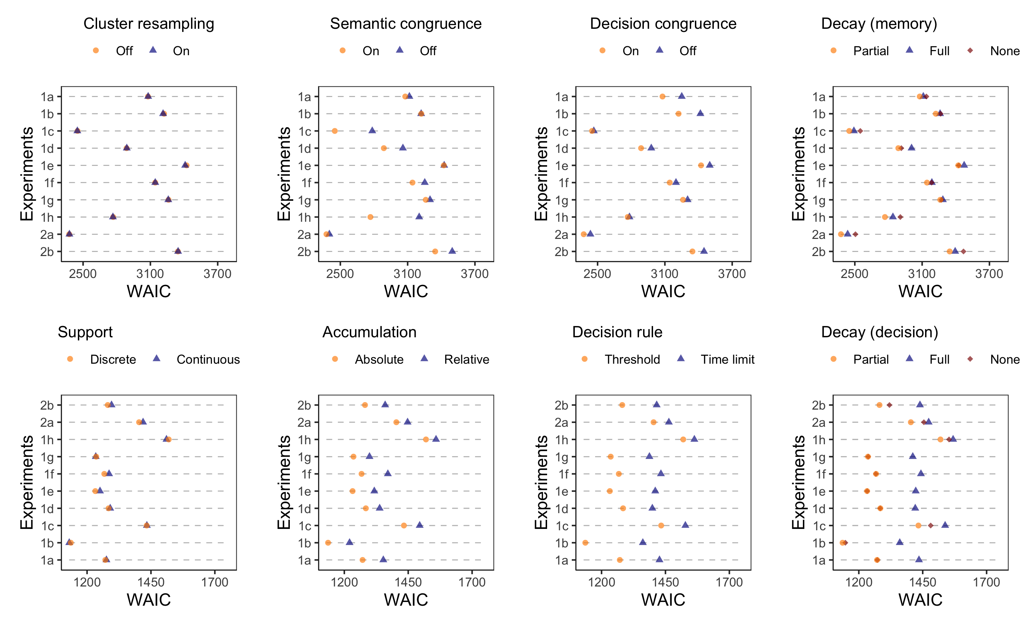

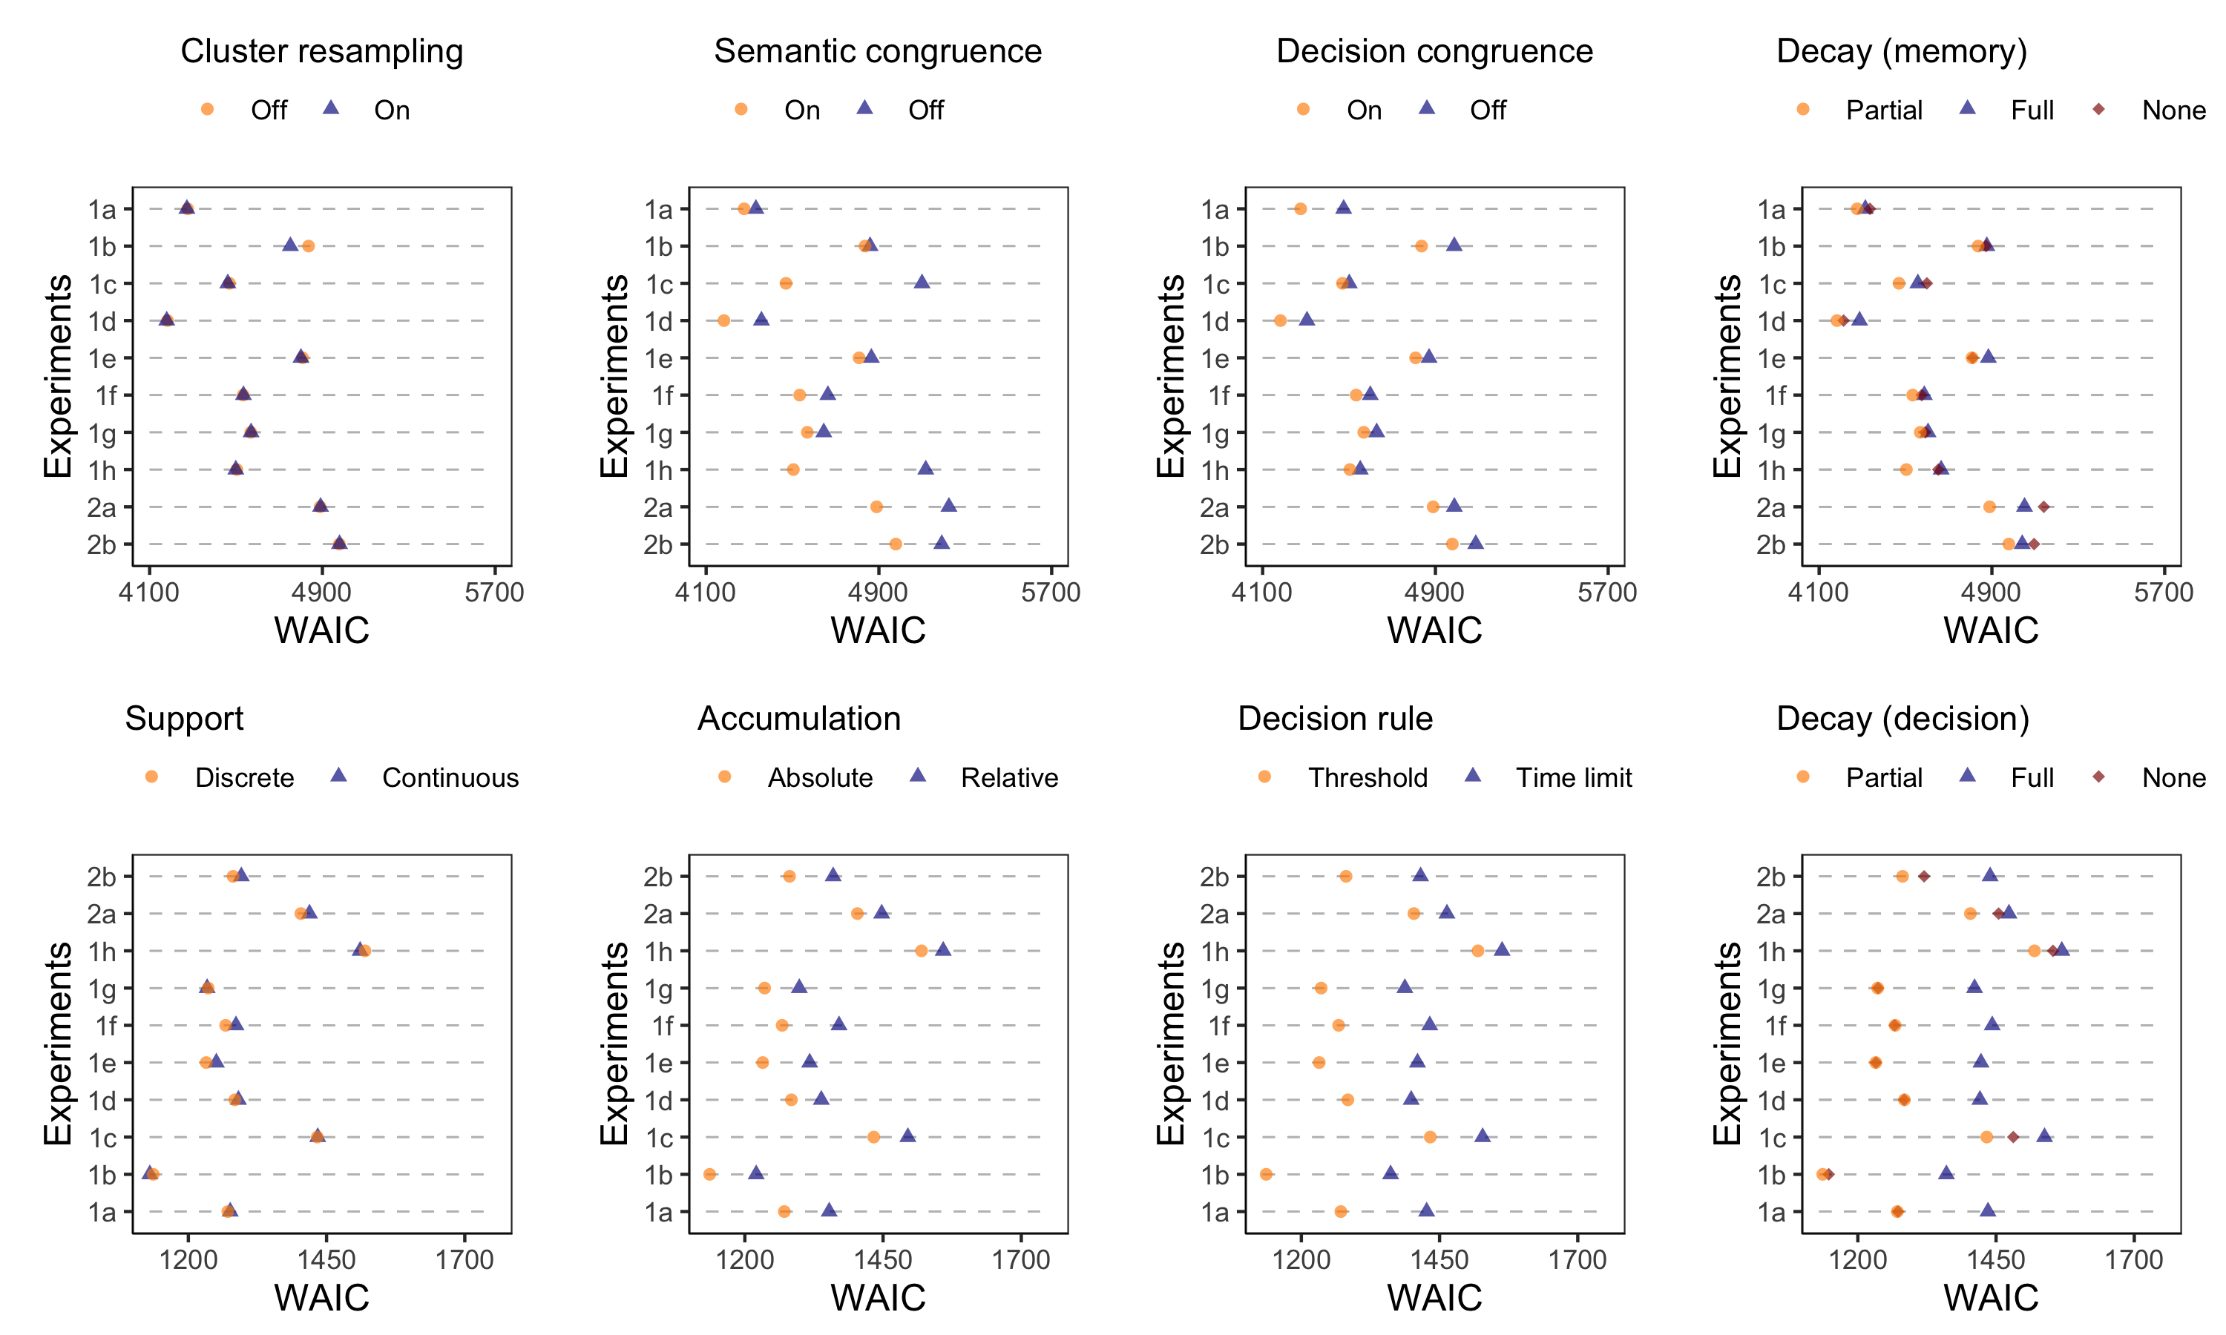

*Figure 2S.* Parameter values for the full memory model (assuming flexible cluster resampling, semantic congruence and decision congruence with partial context decay). The dots represent posterior means, and the error bars indicate 95% credible intervals. The first row is based on *k*=2 k-means clustering solutions, and the second row is based on *k*=4 k-means solutions.

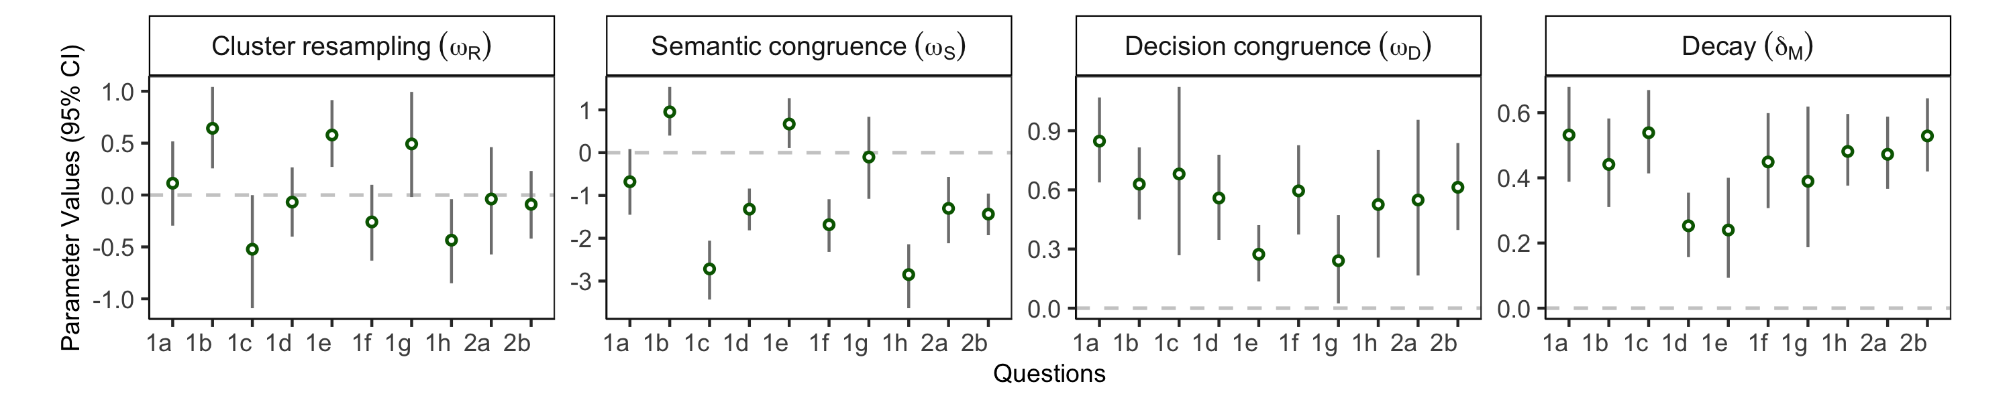

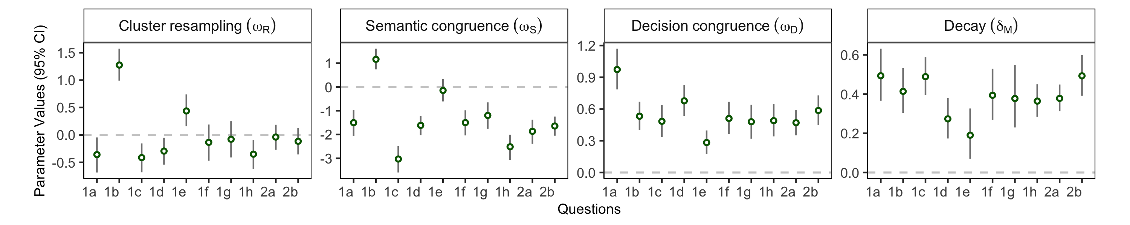

*Figure 3S.* Distributions of thought clusters from the *k* = 2 clustering solution (upper panel) and *k* = 4 clustering solution (lower panel). Here O1-CX represent clusters for thoughts supporting the first option. Neutral-C1 represents the cluster for all neutral thoughts. O2-CX represent clusters for thoughts supporting the second option. The primary model, with semantic and decision congruence and partial context decay but no cluster resampling, provides almost perfect predictions of the observed cluster proportions. However, so do models that turn decision and semantic congruence off. Note that all models have flexible baseline cluster activation parameters, allowing them to accommodate aggregate thought cluster distributions.

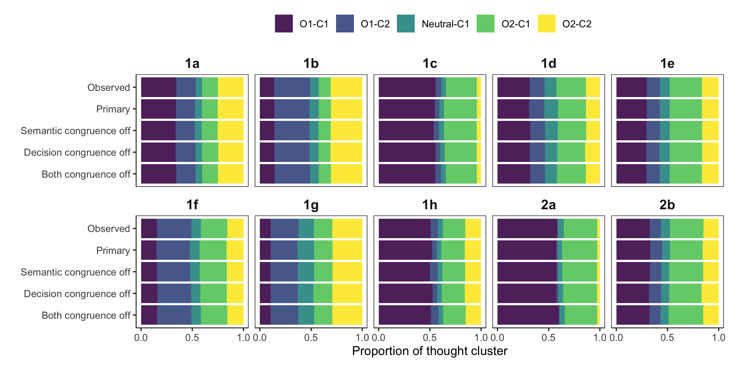

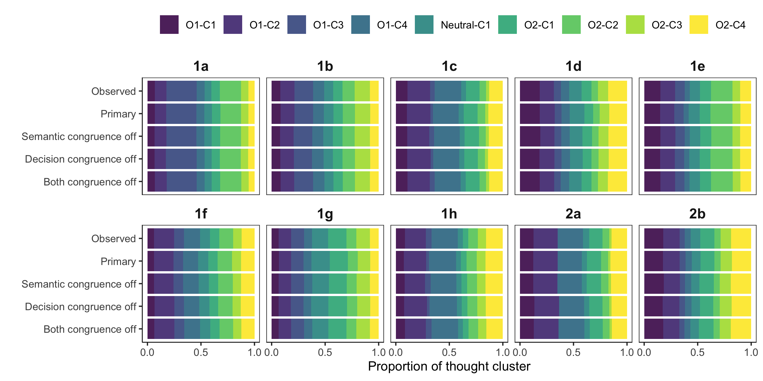

*Figure 4S.* Mean semantic distance between neighboring thoughts, based on *k*=2 k-means clustering solution (upper panel) and *k*=4 k-means clustering solution (lower panel). Note that the primary model has both semantic and decision congruence turned on. All the models presented here have cluster resampling off and partial context decay on. Models without semantic congruence parameters overpredict semantic distances between neighboring thoughts. Error bars indicate standard errors across participants.

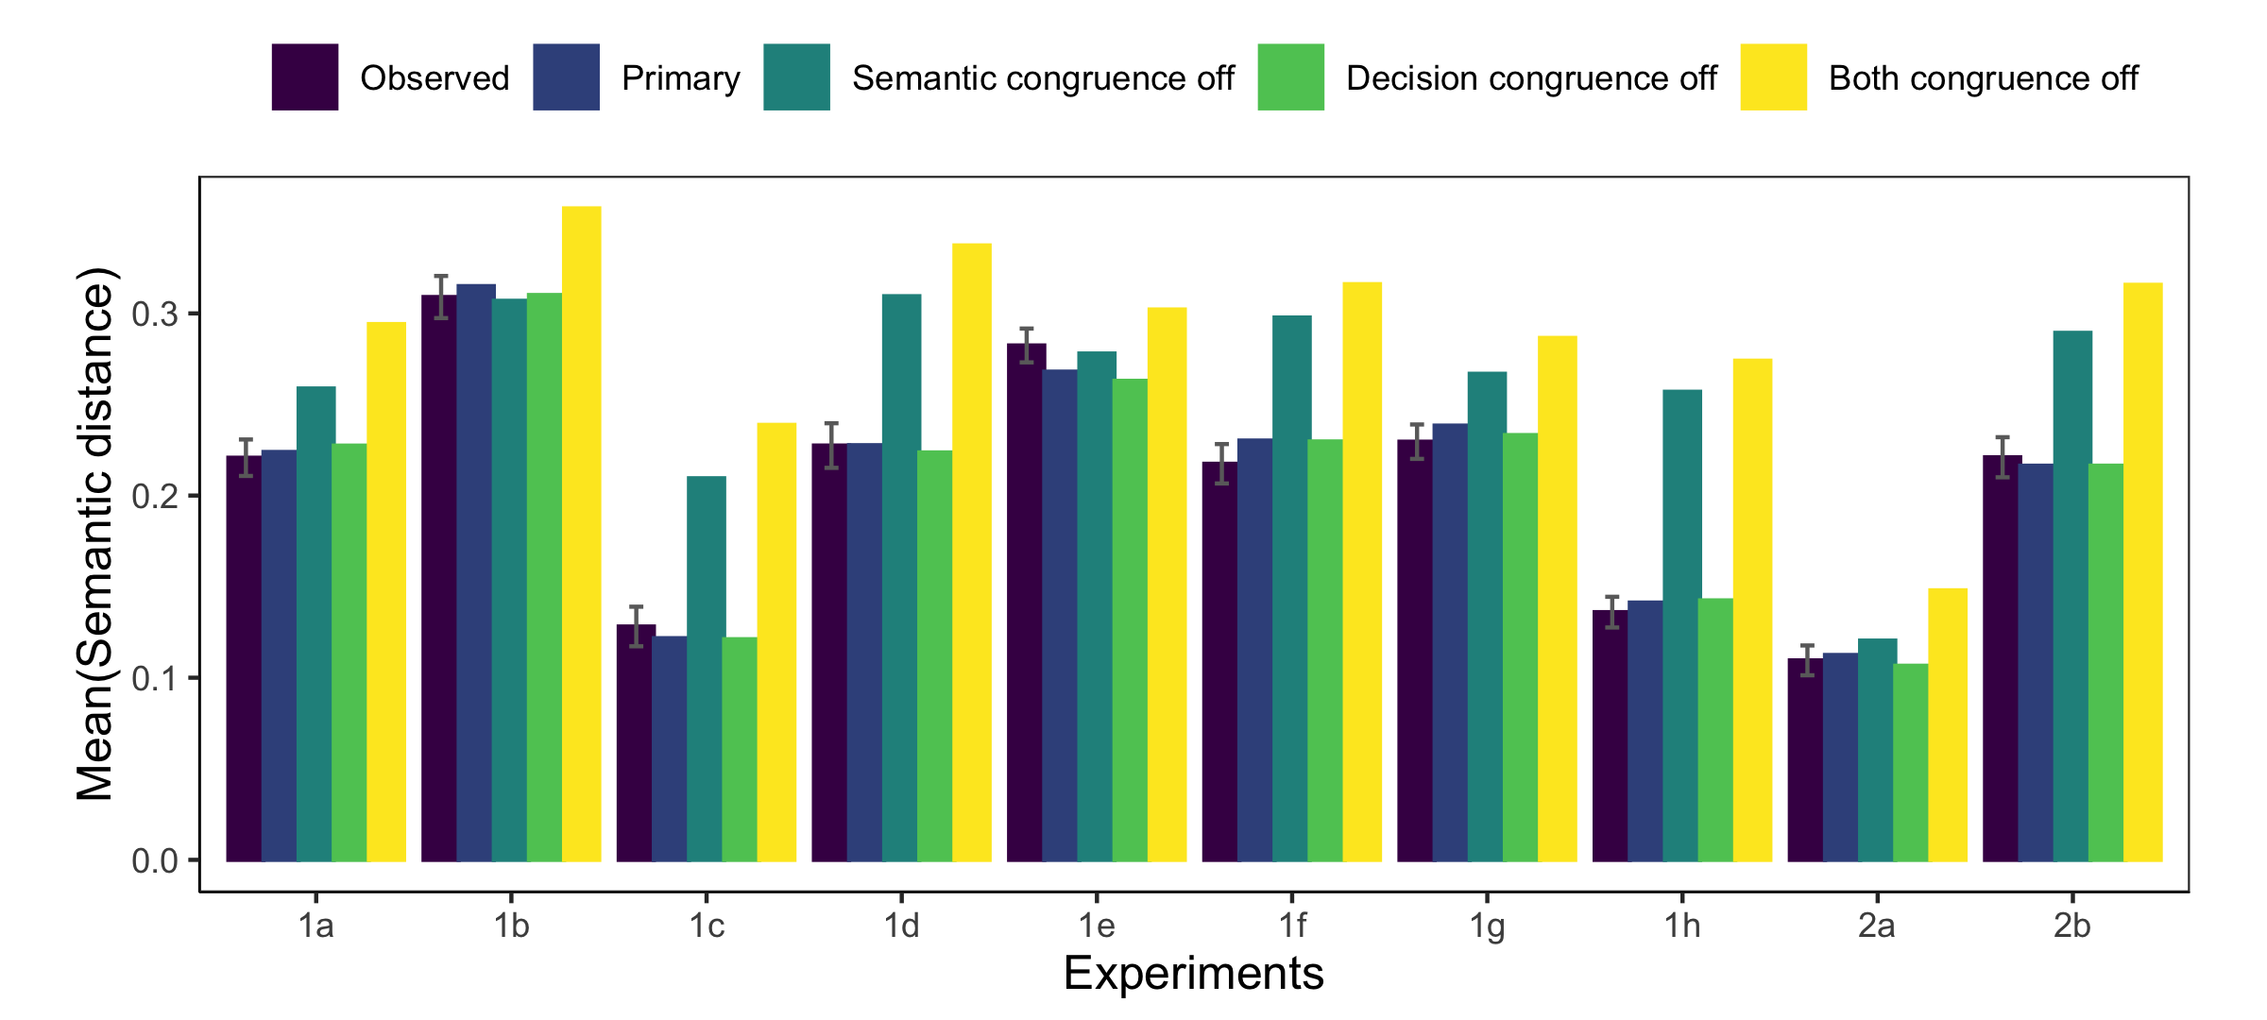

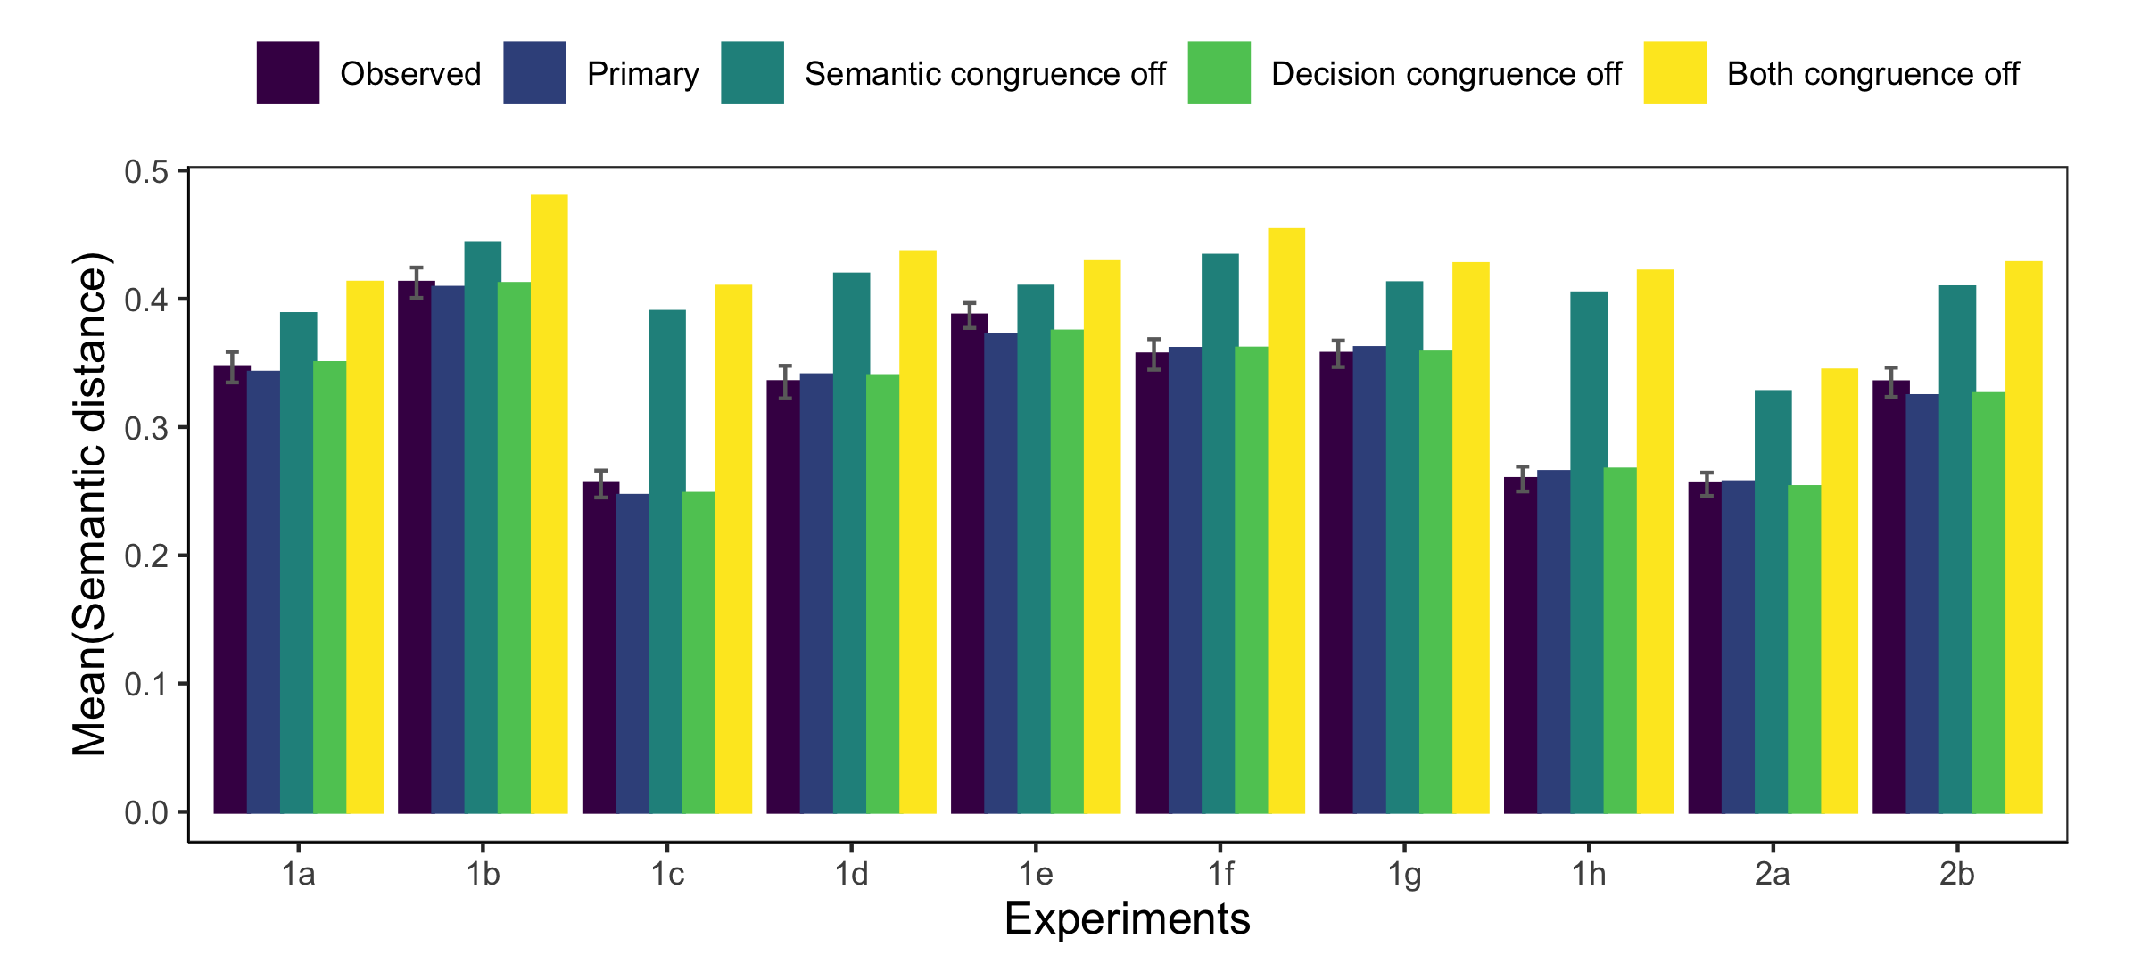

*Figure 5S.* Probability of sampling a decision-congruent thought cluster, based on *k*=2 k-means clustering solution (upper panel) and *k*=4 k-means clustering solution (lower panel). Note that the primary model has both semantic and decision congruence turned on. All the models presented here have cluster resampling off and partial context decay on. Models without decision congruence parameters underpredict the probability of sampling a thought supporting the same option as the previous thought. Error bars indicate standard errors across participants.

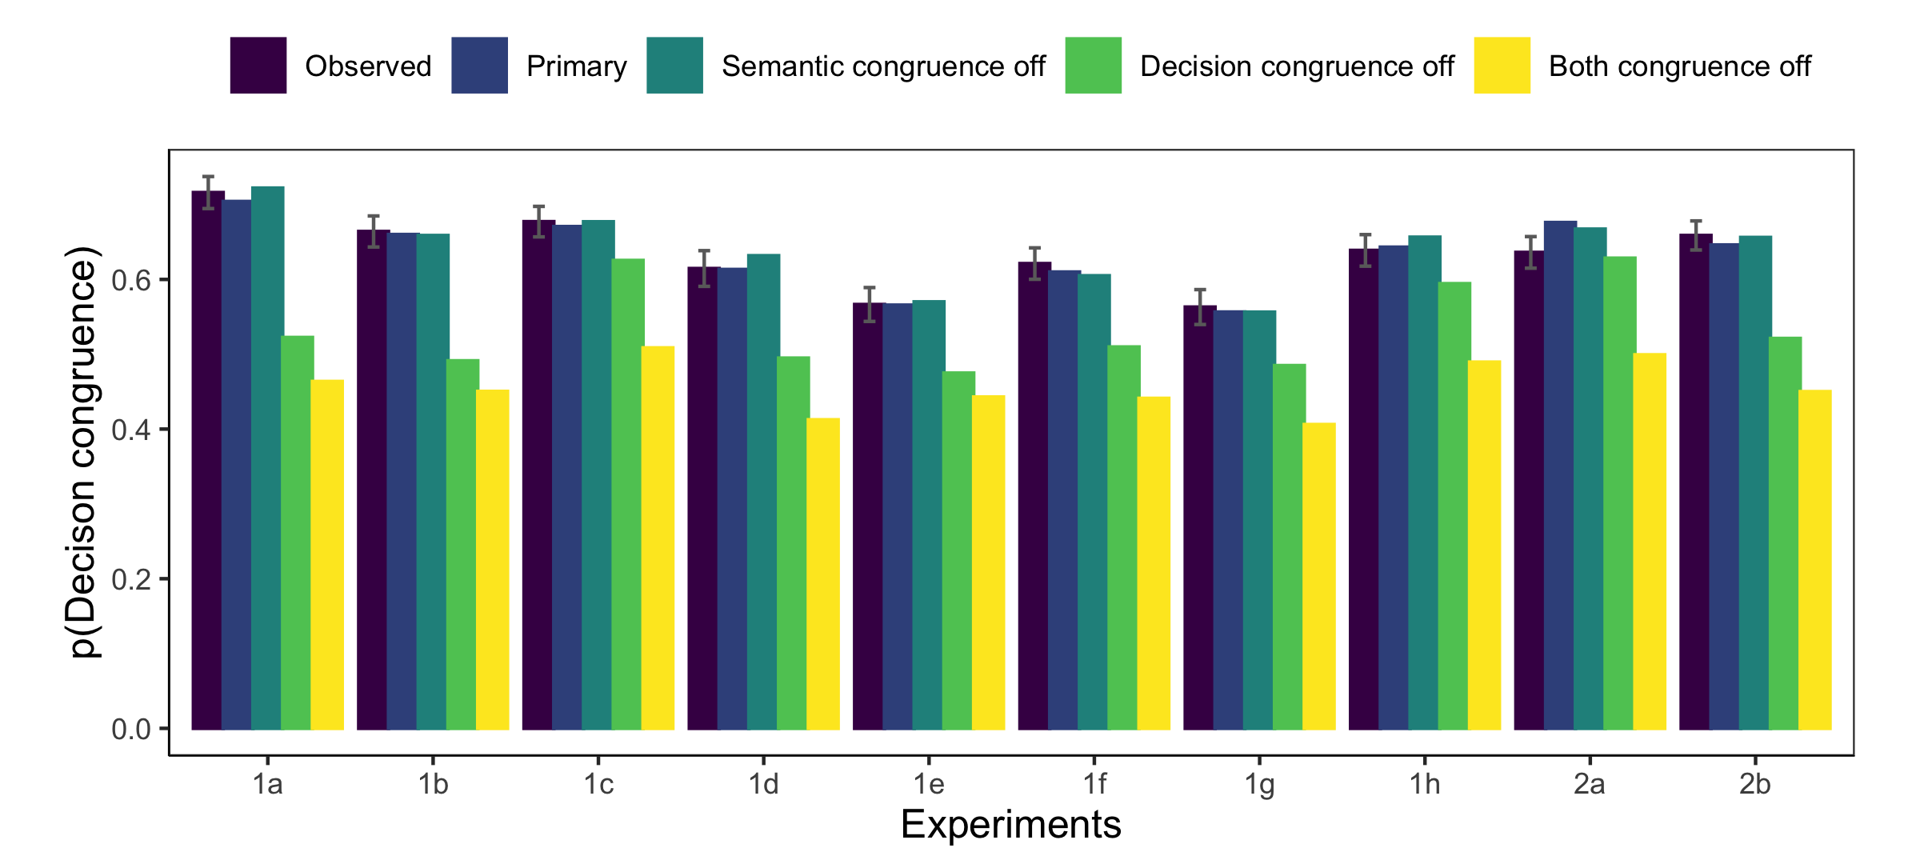

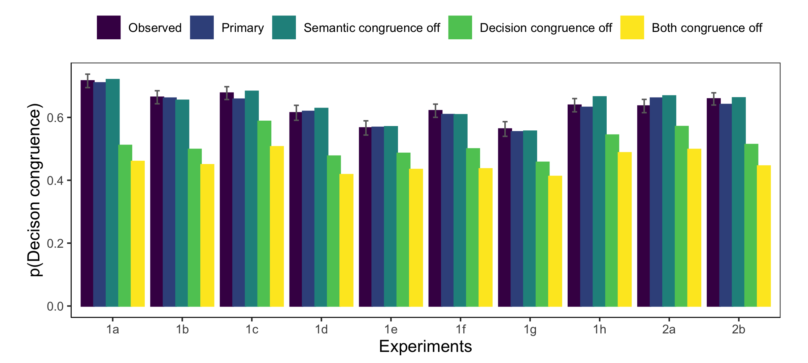

*Figure 6S.* Difference in probability of choosing the first option for condition 1 vs. 2, in Experiments 2a-2b. Predictions are based on *k*=2 k-means clustering solution (upper panel) and *k*=4 k-means clustering solution (lower panel). In condition 1 (2) participants were asked to list a thought supporting the choice of the first (second) option first. In both experiments, participants in condition 1 are more likely to indicate the first option as their final answer. The model with both semantic and decision congruence turned off cannot capture this pattern as well as the other models. All the models presented here have cluster resampling off and partial context decay on. Posterior samples of parameters from Experiments 1c-1d (where the same decision prompts are shown to participants as in Experiments 2a-2b) are used to simulate model predictions. Error bars indicate standard errors.

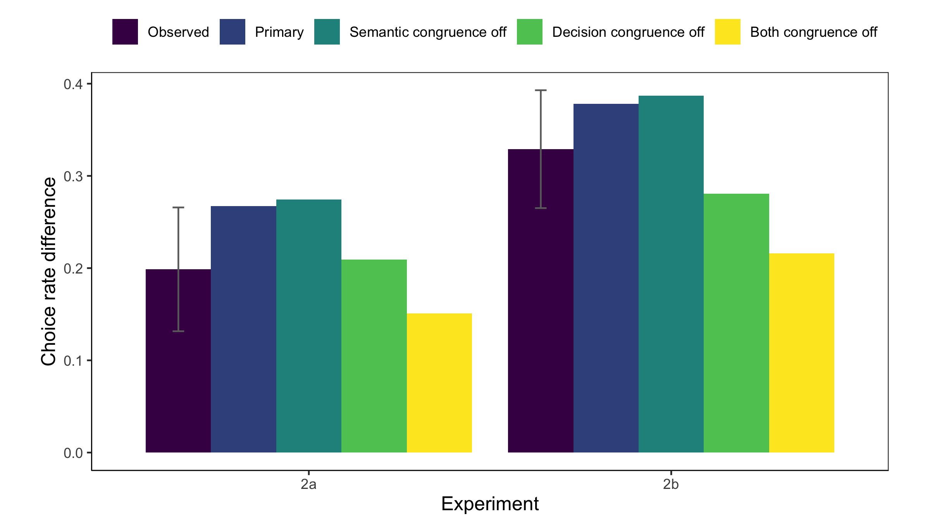

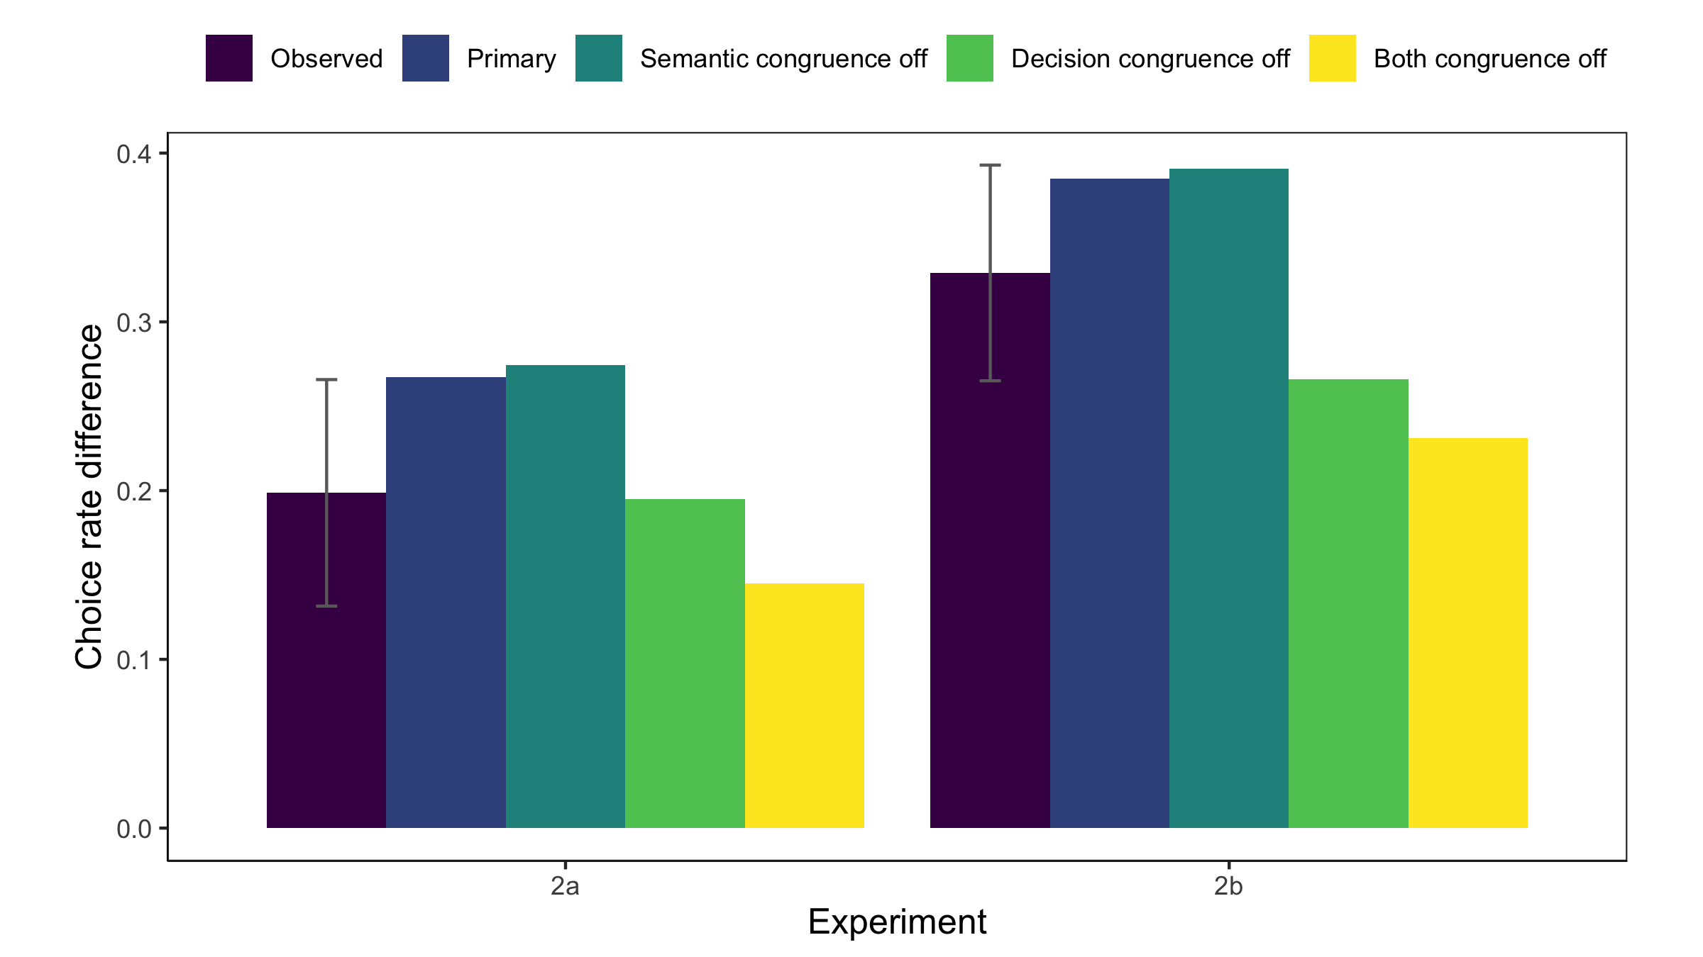

*Figure 7S.* Distributions of thought clusters supporting different options in Experiments 2a and 2b, *after excluding the first thought*. Predictions are based on *k*=2 k-means clustering solution (upper panels) and *k*=4 k-means clustering solution (lower panels). We observe higher sampling proportions for thought clusters supporting first option for participants in condition 1 (start with a though supporting the first option) (top panel). The opposite is true for participants in condition 2 (start with a thought supporting the second option) (bottom panel). This pattern is best captured by models with decision congruence on. Note that the primary model has both semantic and decision congruence turned on. All the models presented here have cluster resampling off and partial context decay on. Posterior samples of parameters from Experiments 1c-1d (where the same decision prompts are shown to participants as in Experiments 2a-2b) are used to simulate model predictions.

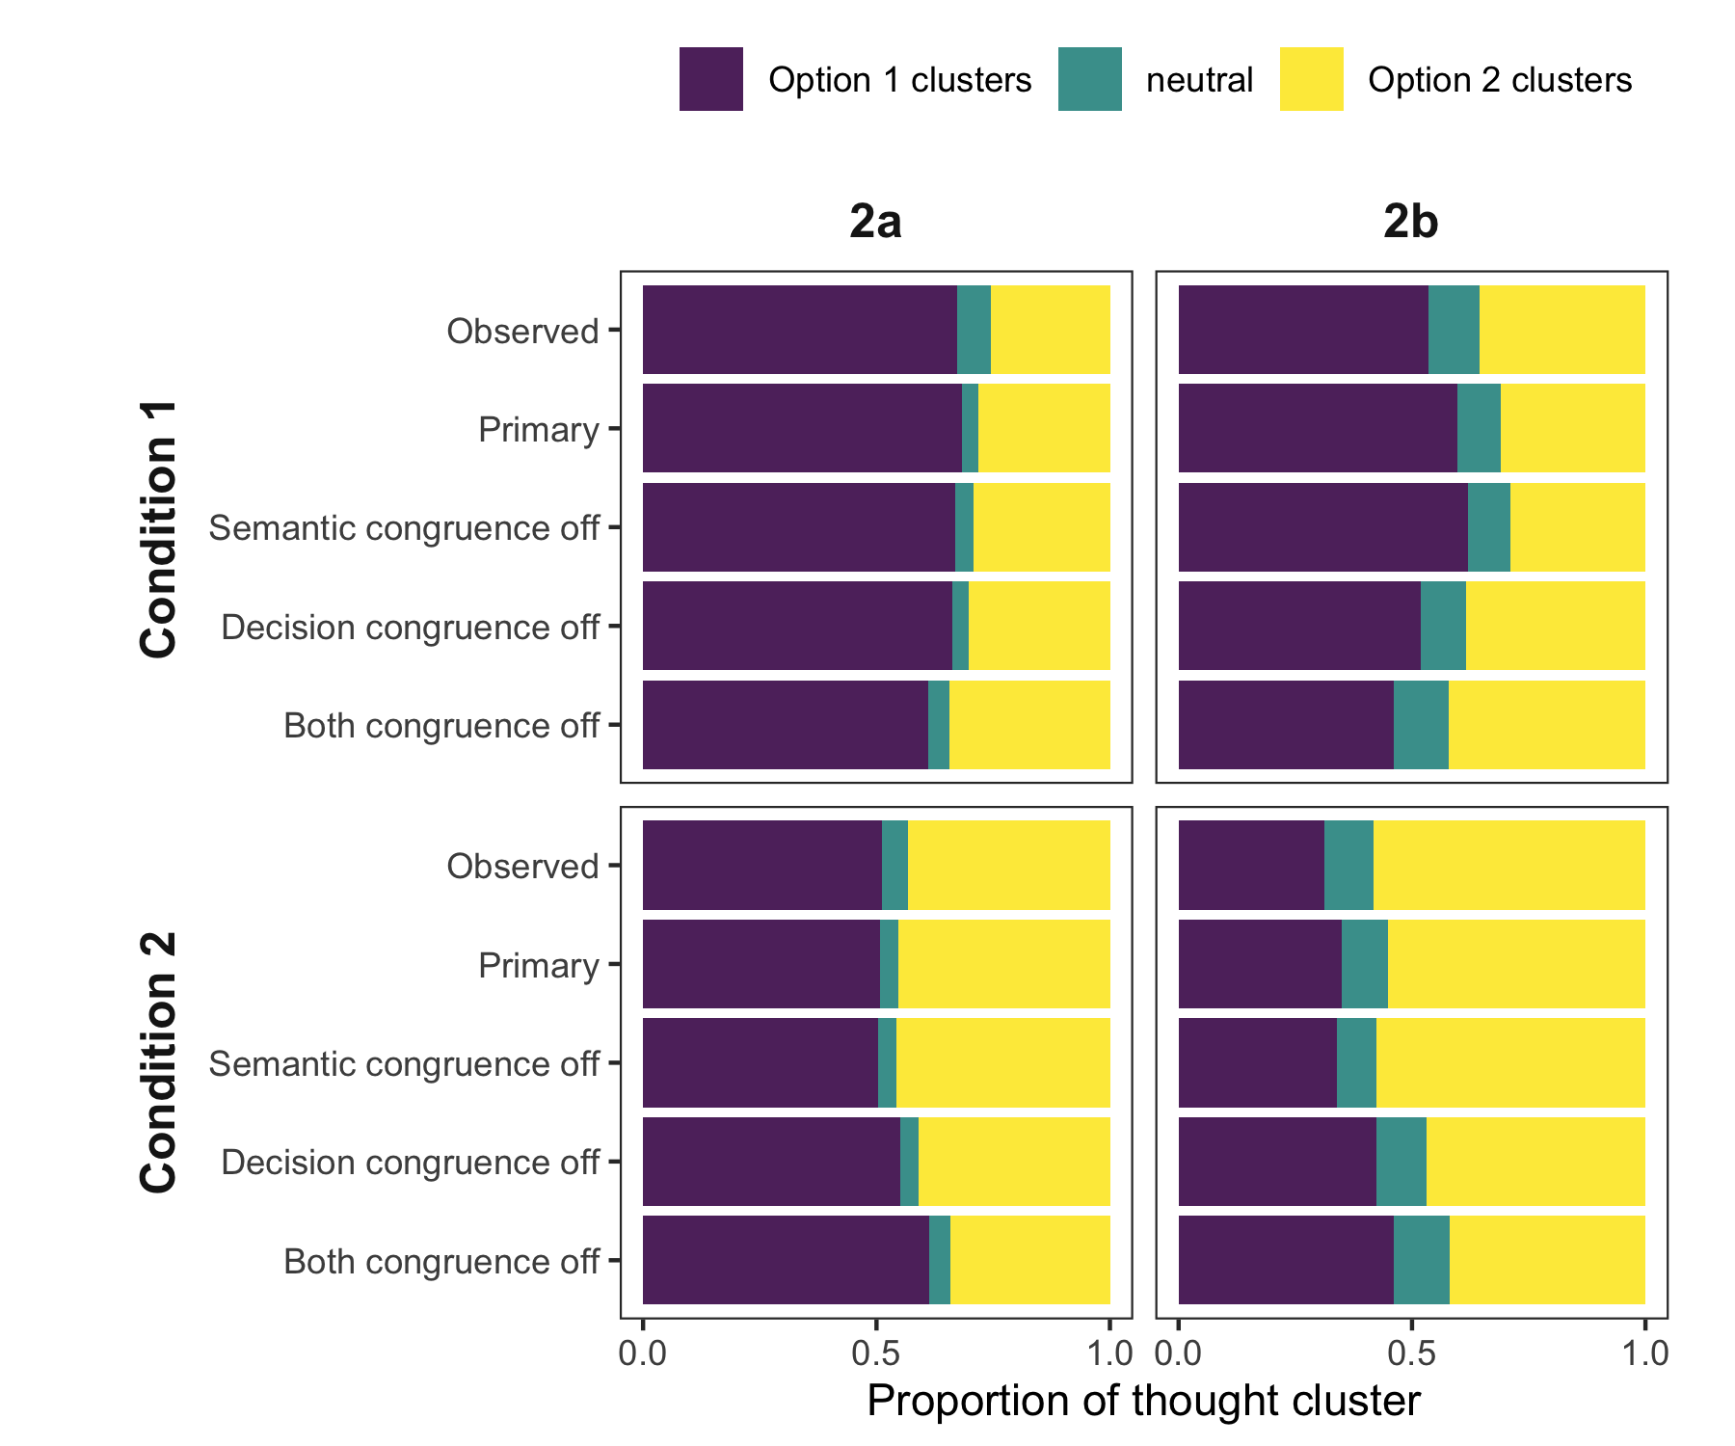

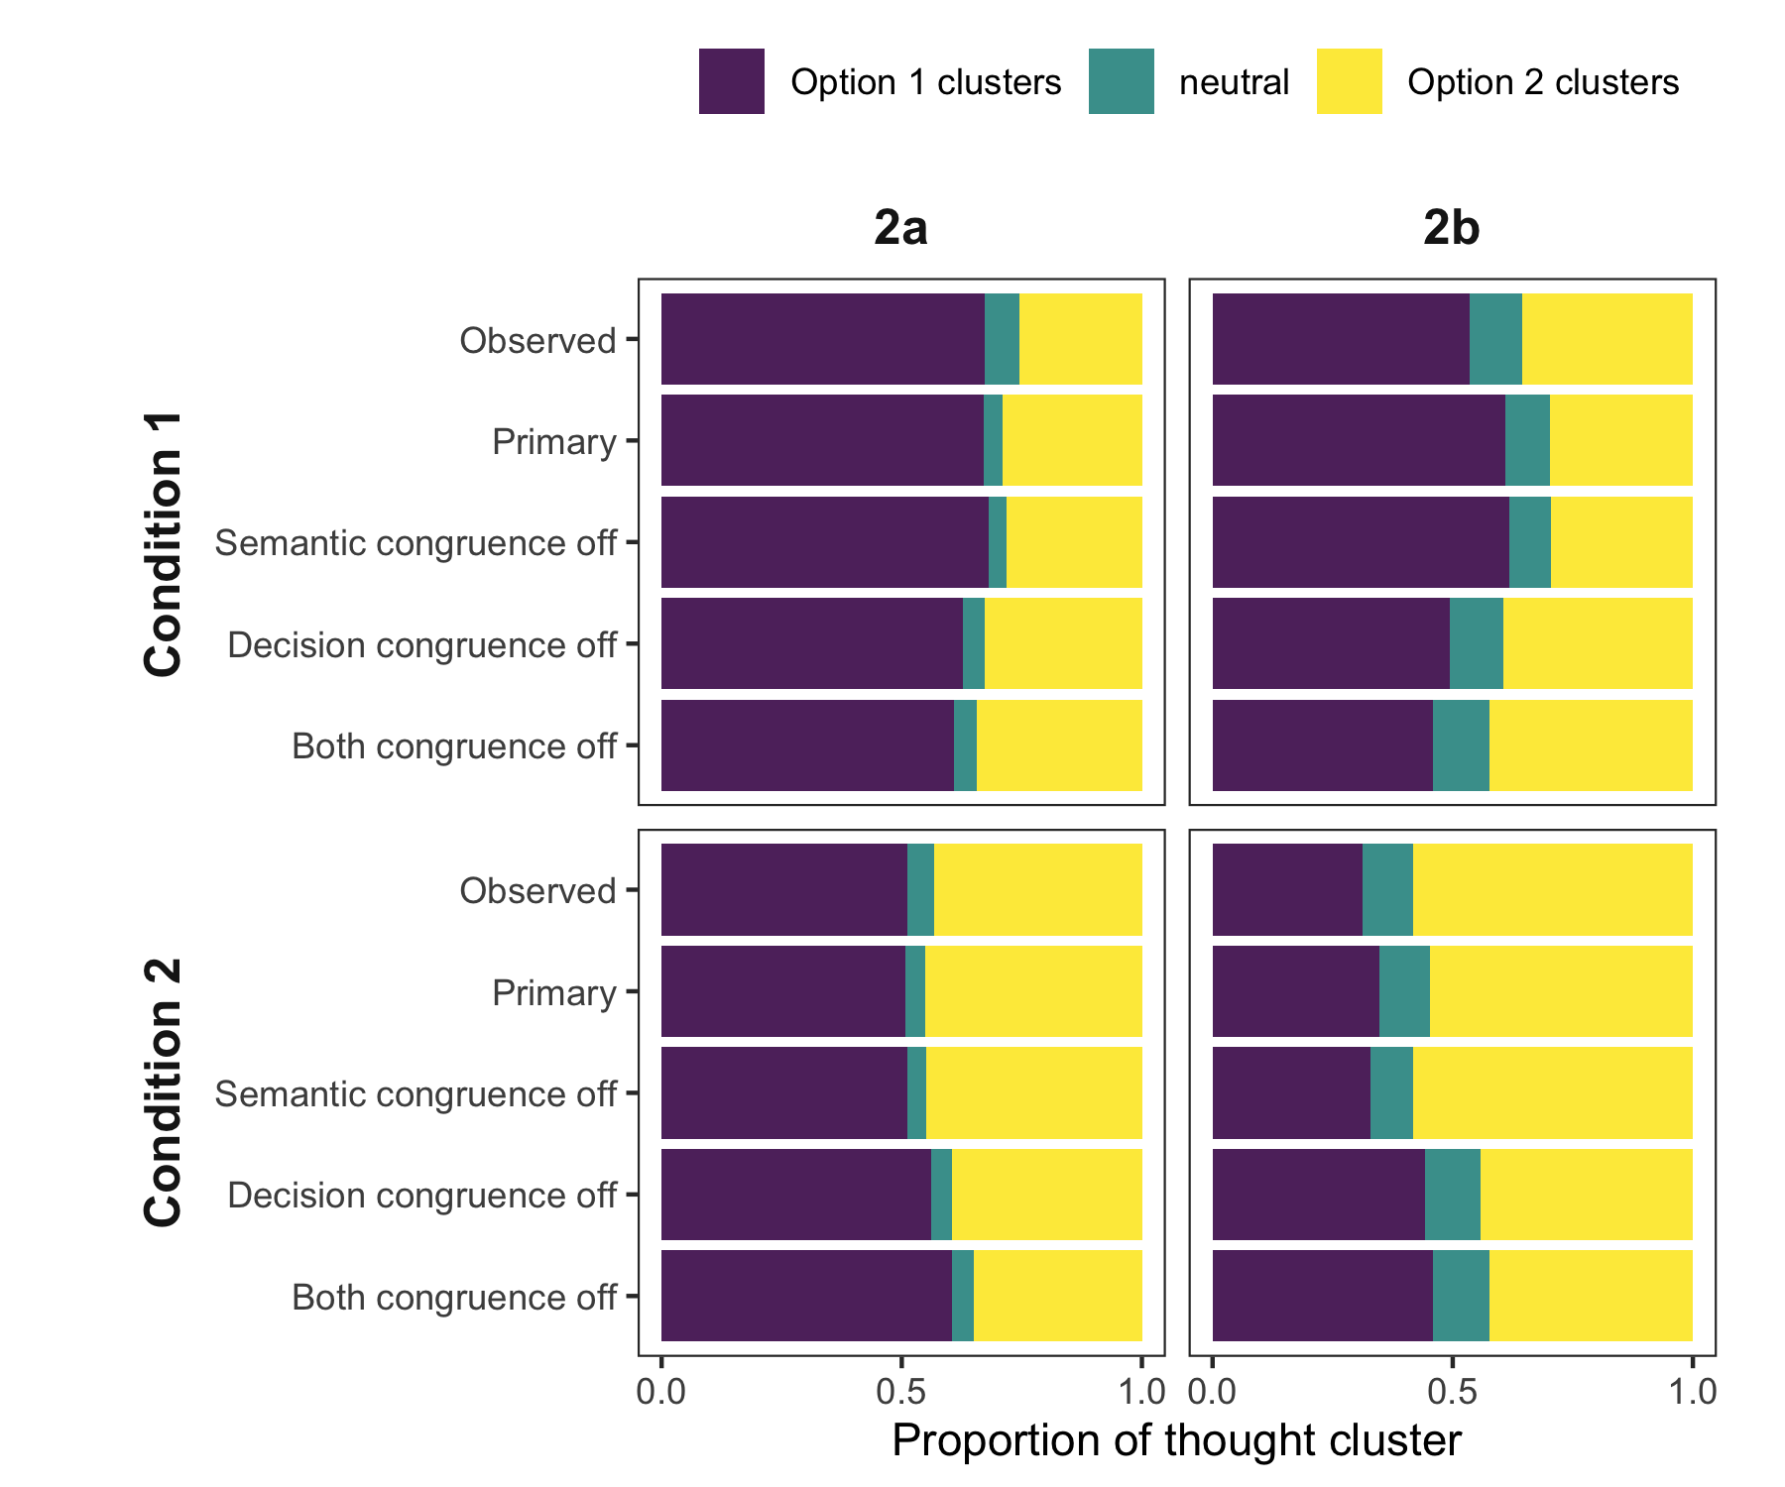

*Figure 8S.* Parameter recovery for the full memory model and the primary decision model (absolute accumulation of discrete supports towards a threshold with partial context decay). Thought cluster and decision data were simulated using 506 sets of true parameter values. Semantic distances are based on the *k* = 3 *k*-means thought clustering solutions. Each simulated dataset is associated with one randomly selected semantic distance matrix from the eight questions (indicated by different colors). The panels compare generating values (x-axis) and recovered values (y-axis) for different parameters.

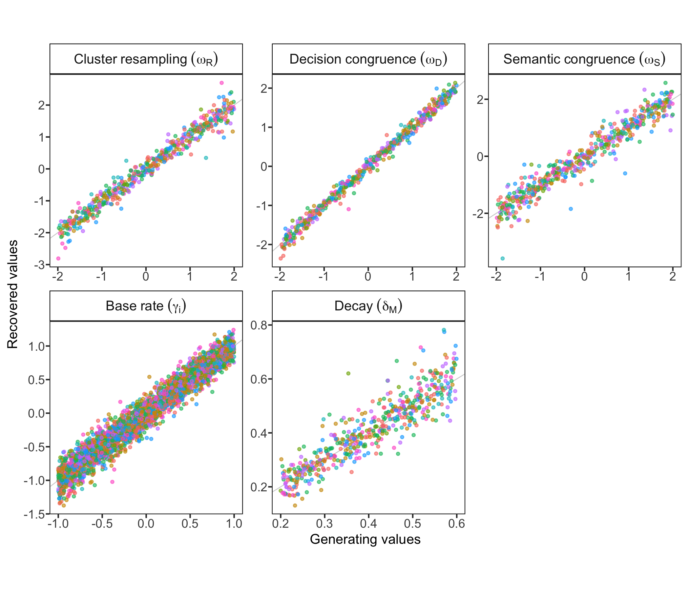

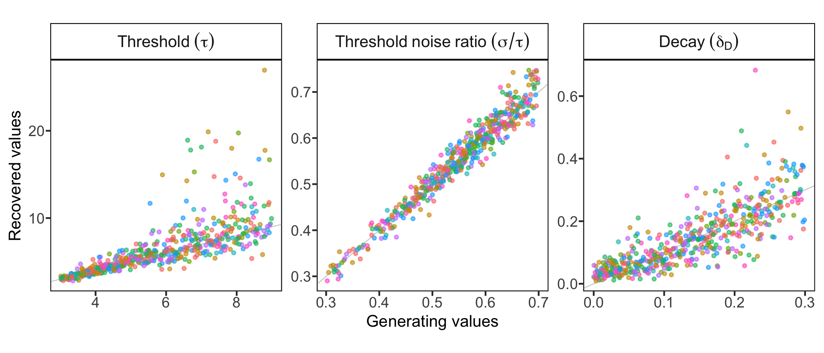

*Figure 9S.* Parameter recovery for the full memory model and the primary decision model (absolute accumulation of discrete supports towards a threshold with partial context decay): correlations between recovered parameter values. There are no correlations among memory model parameters, and some correlations among decision model parameters (though these are mostly driven by extreme values not observed in our model fits, e.g., threshold mean parameters that are larger than 10 and decision decay parameters that are larger than 0.4).

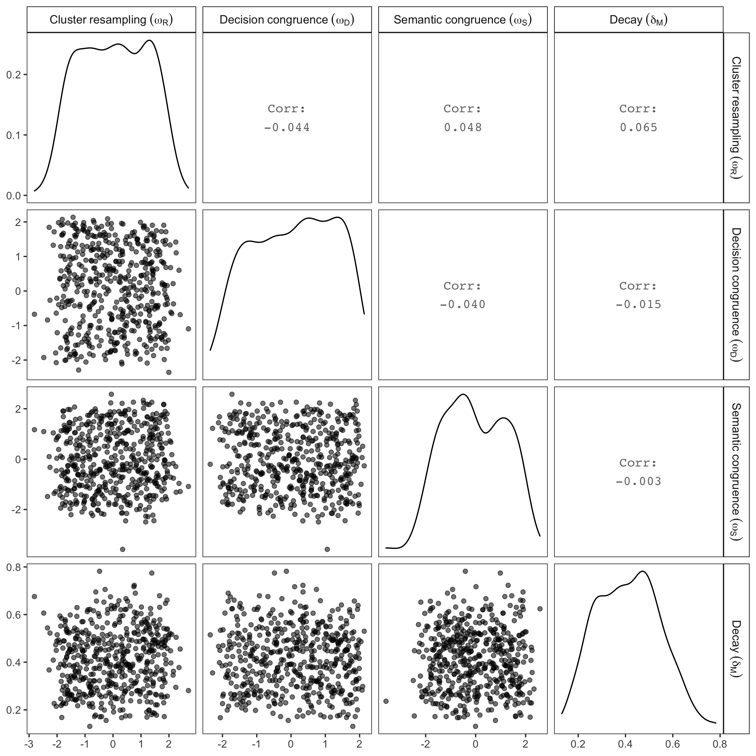

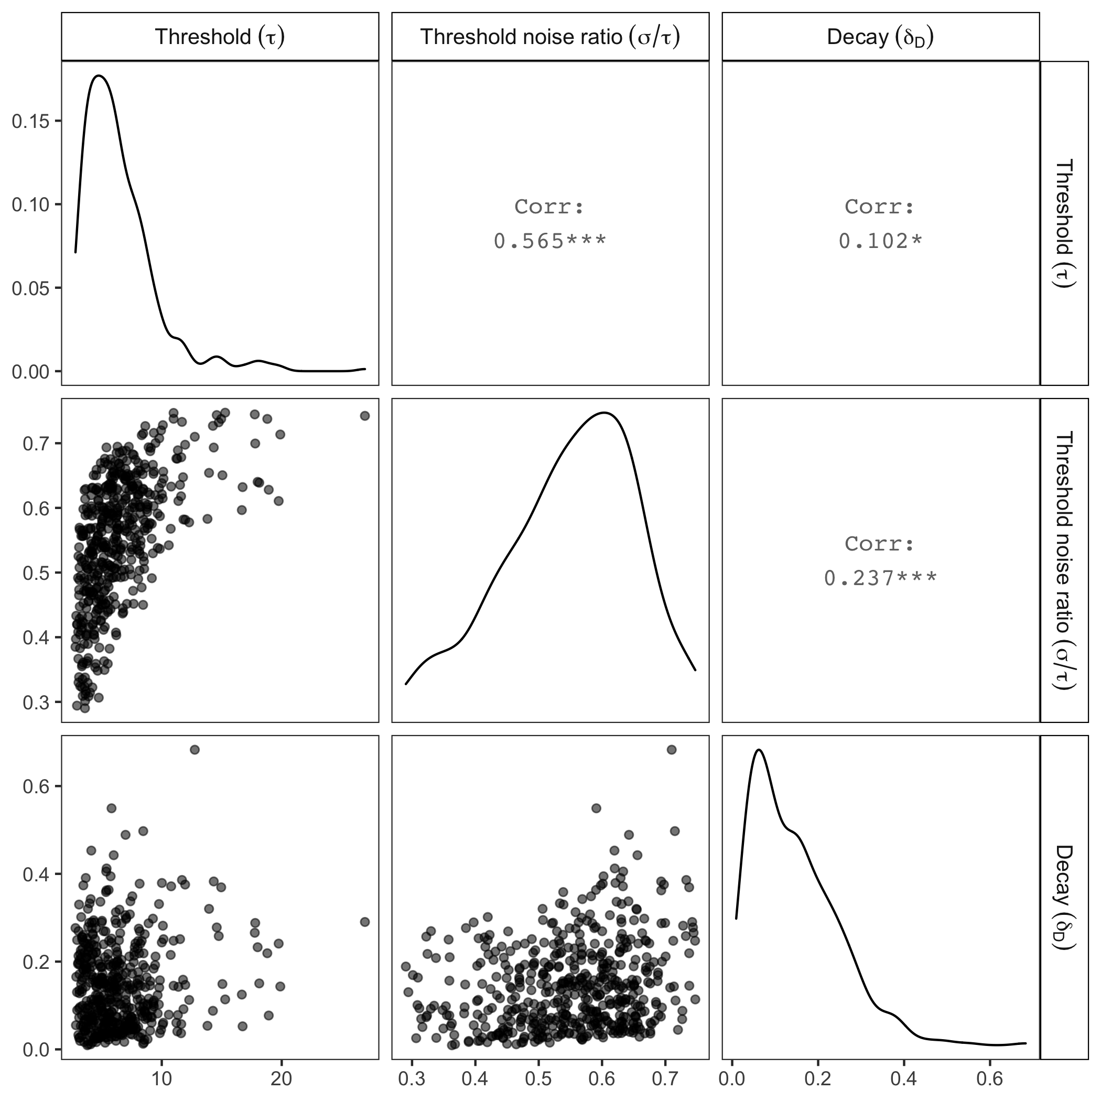

*Figure 10S.* Parameter recovery for the full memory model and the decision model assuming relative accumulation of discrete supports towards a threshold with partial context decay. Thought cluster and decision data were simulated using 431 sets of true parameter values. Semantic distances are based on the *k* = 3 *k*-means thought clustering solutions. Each simulated dataset is associated with one randomly selected semantic distance matrix from the eight questions (indicated by different colors). The panels compare generating values (x-axis) and recovered values (y-axis) for different parameters.

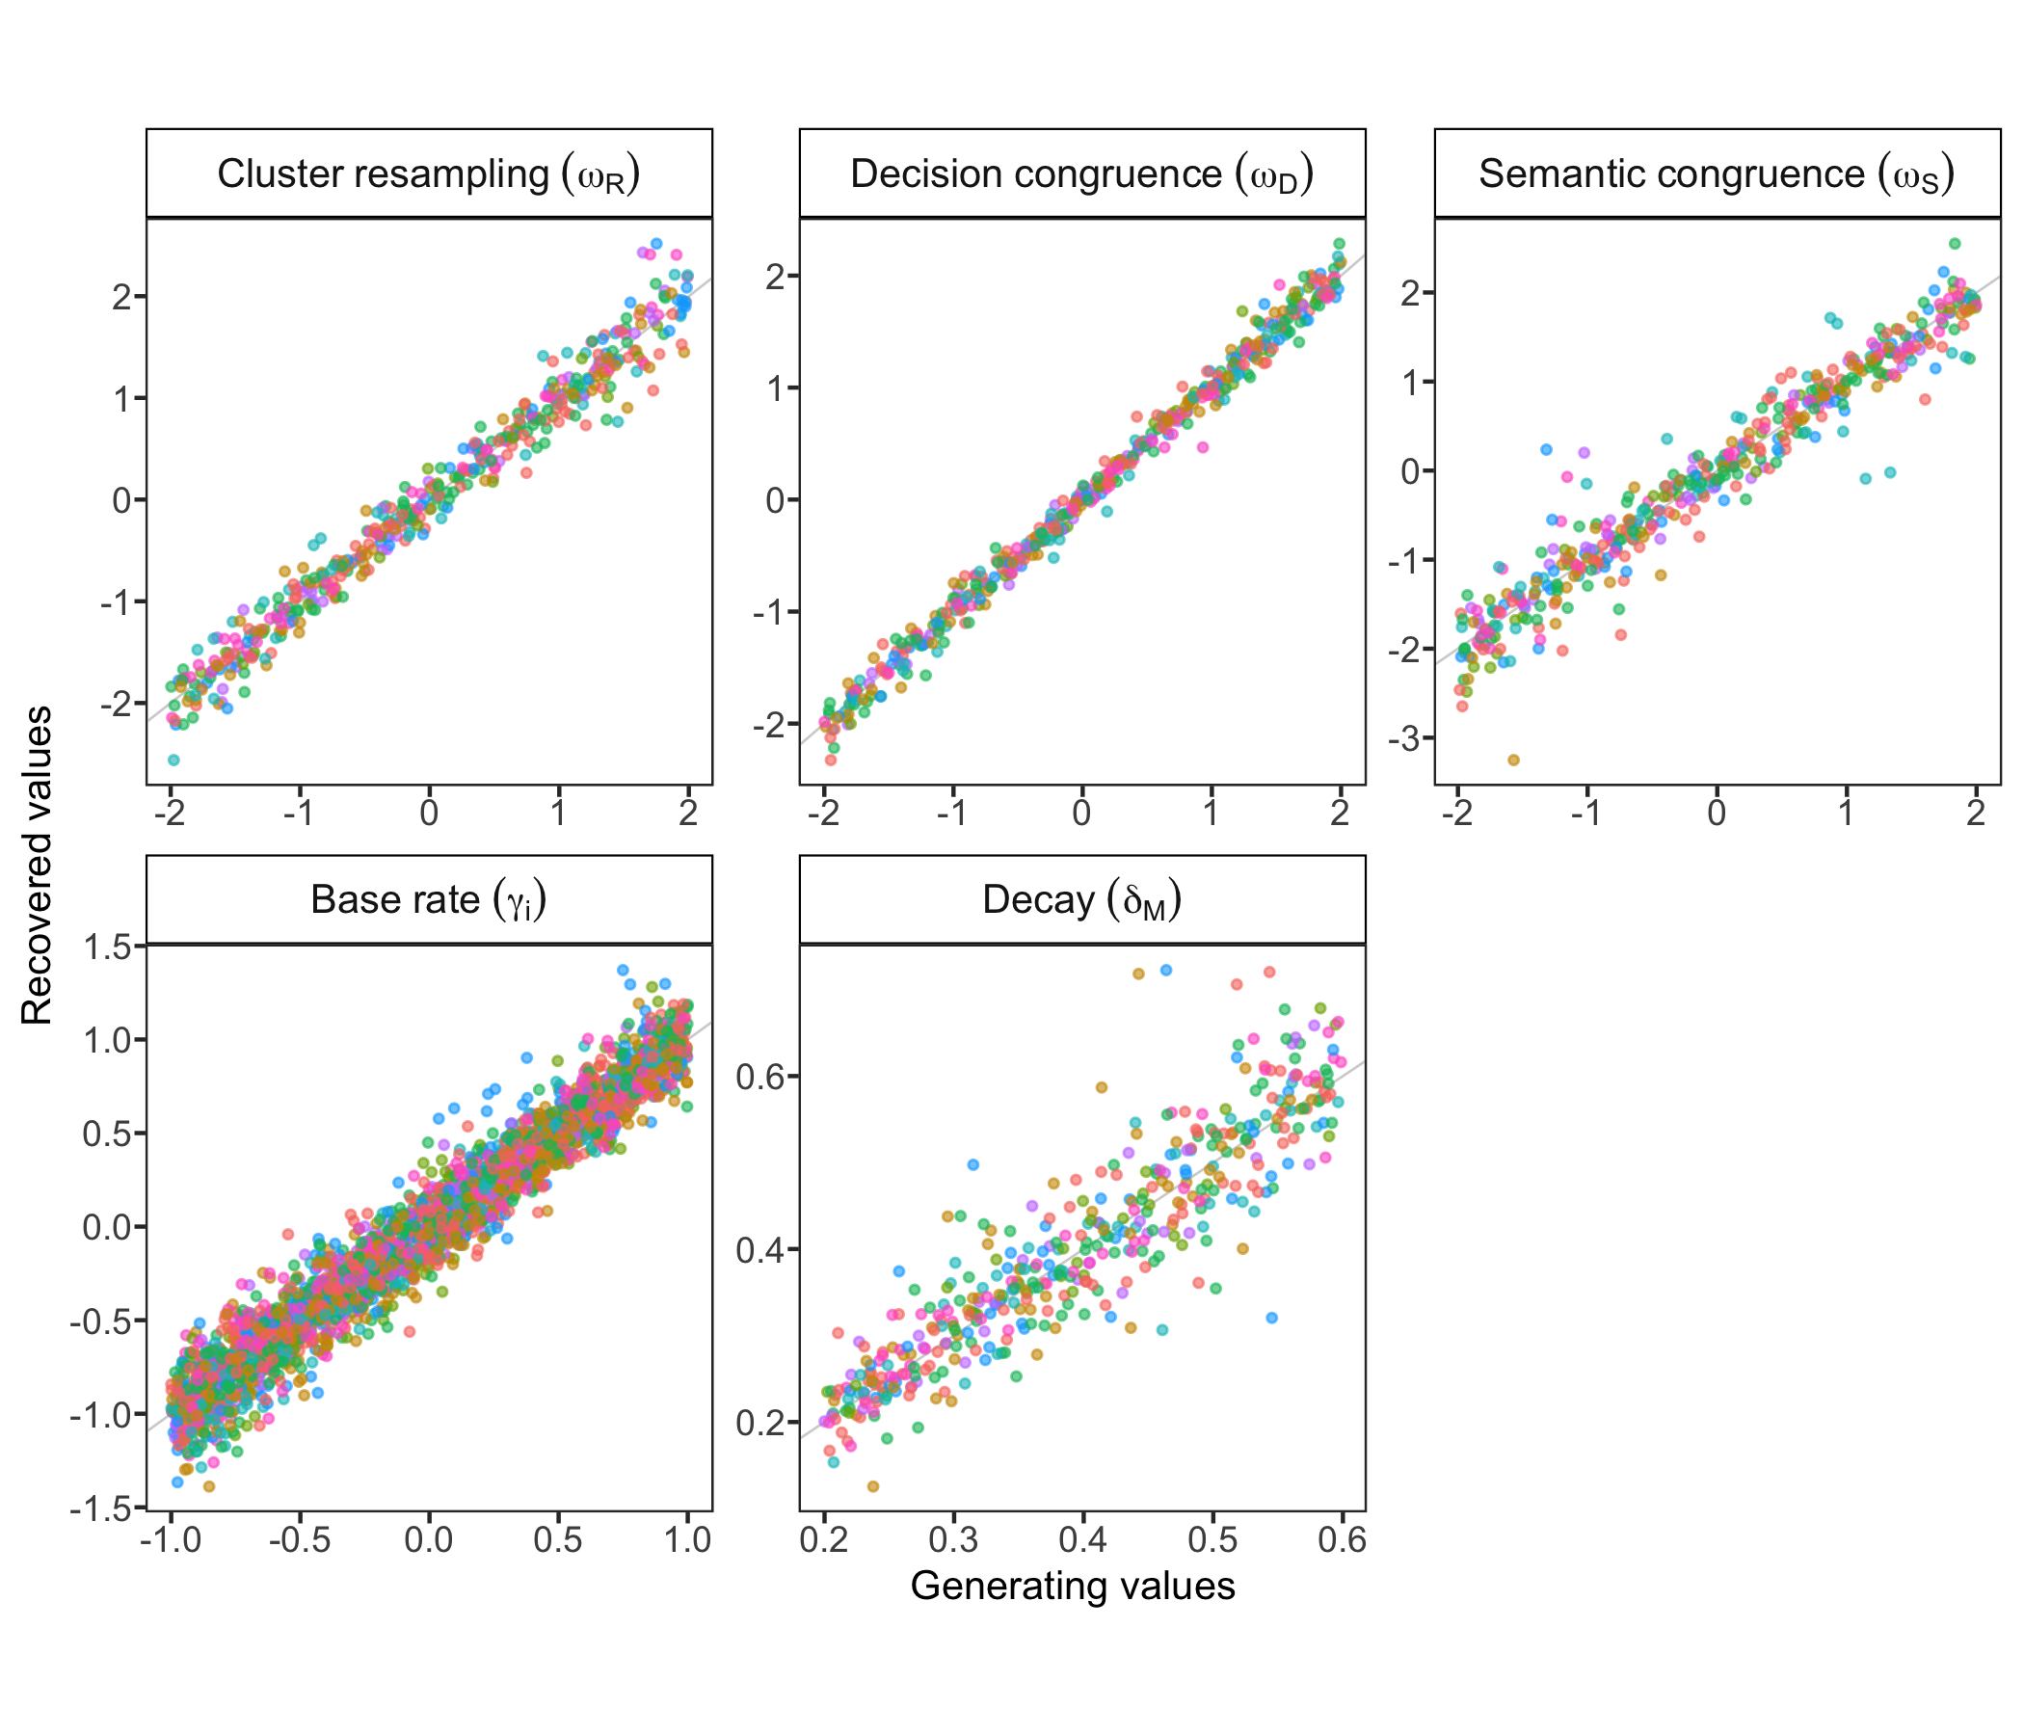

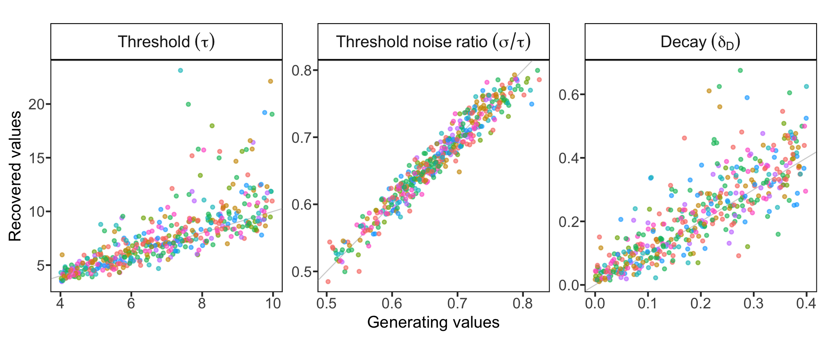

*Figure 11S.* Parameter recovery for the full memory model and the decision model assuming relative accumulation of discrete supports towards a threshold with partial context decay: correlations between recovered parameter values. There are no correlations among memory model parameters, and some correlations among decision model parameters.

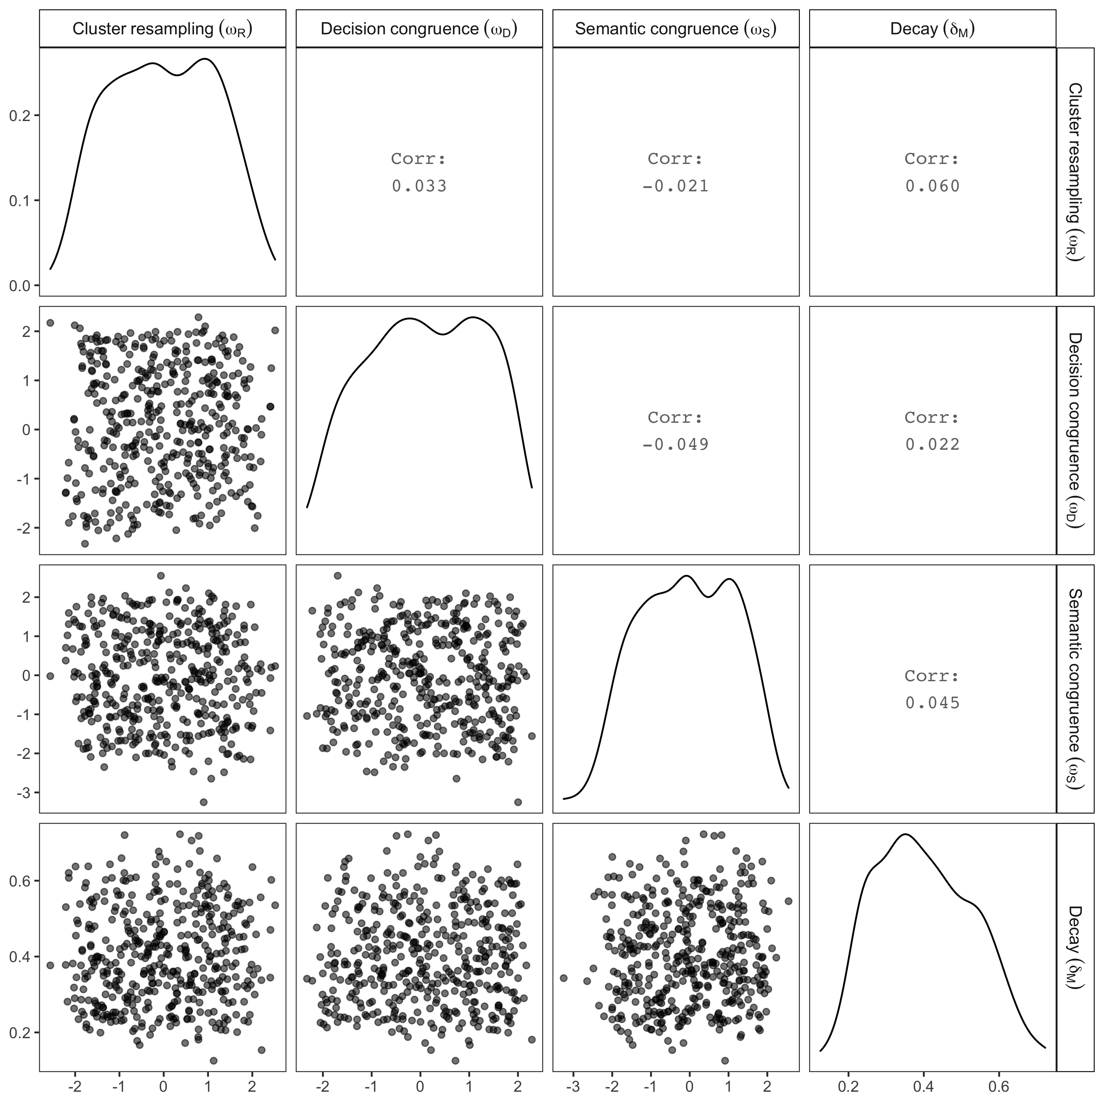

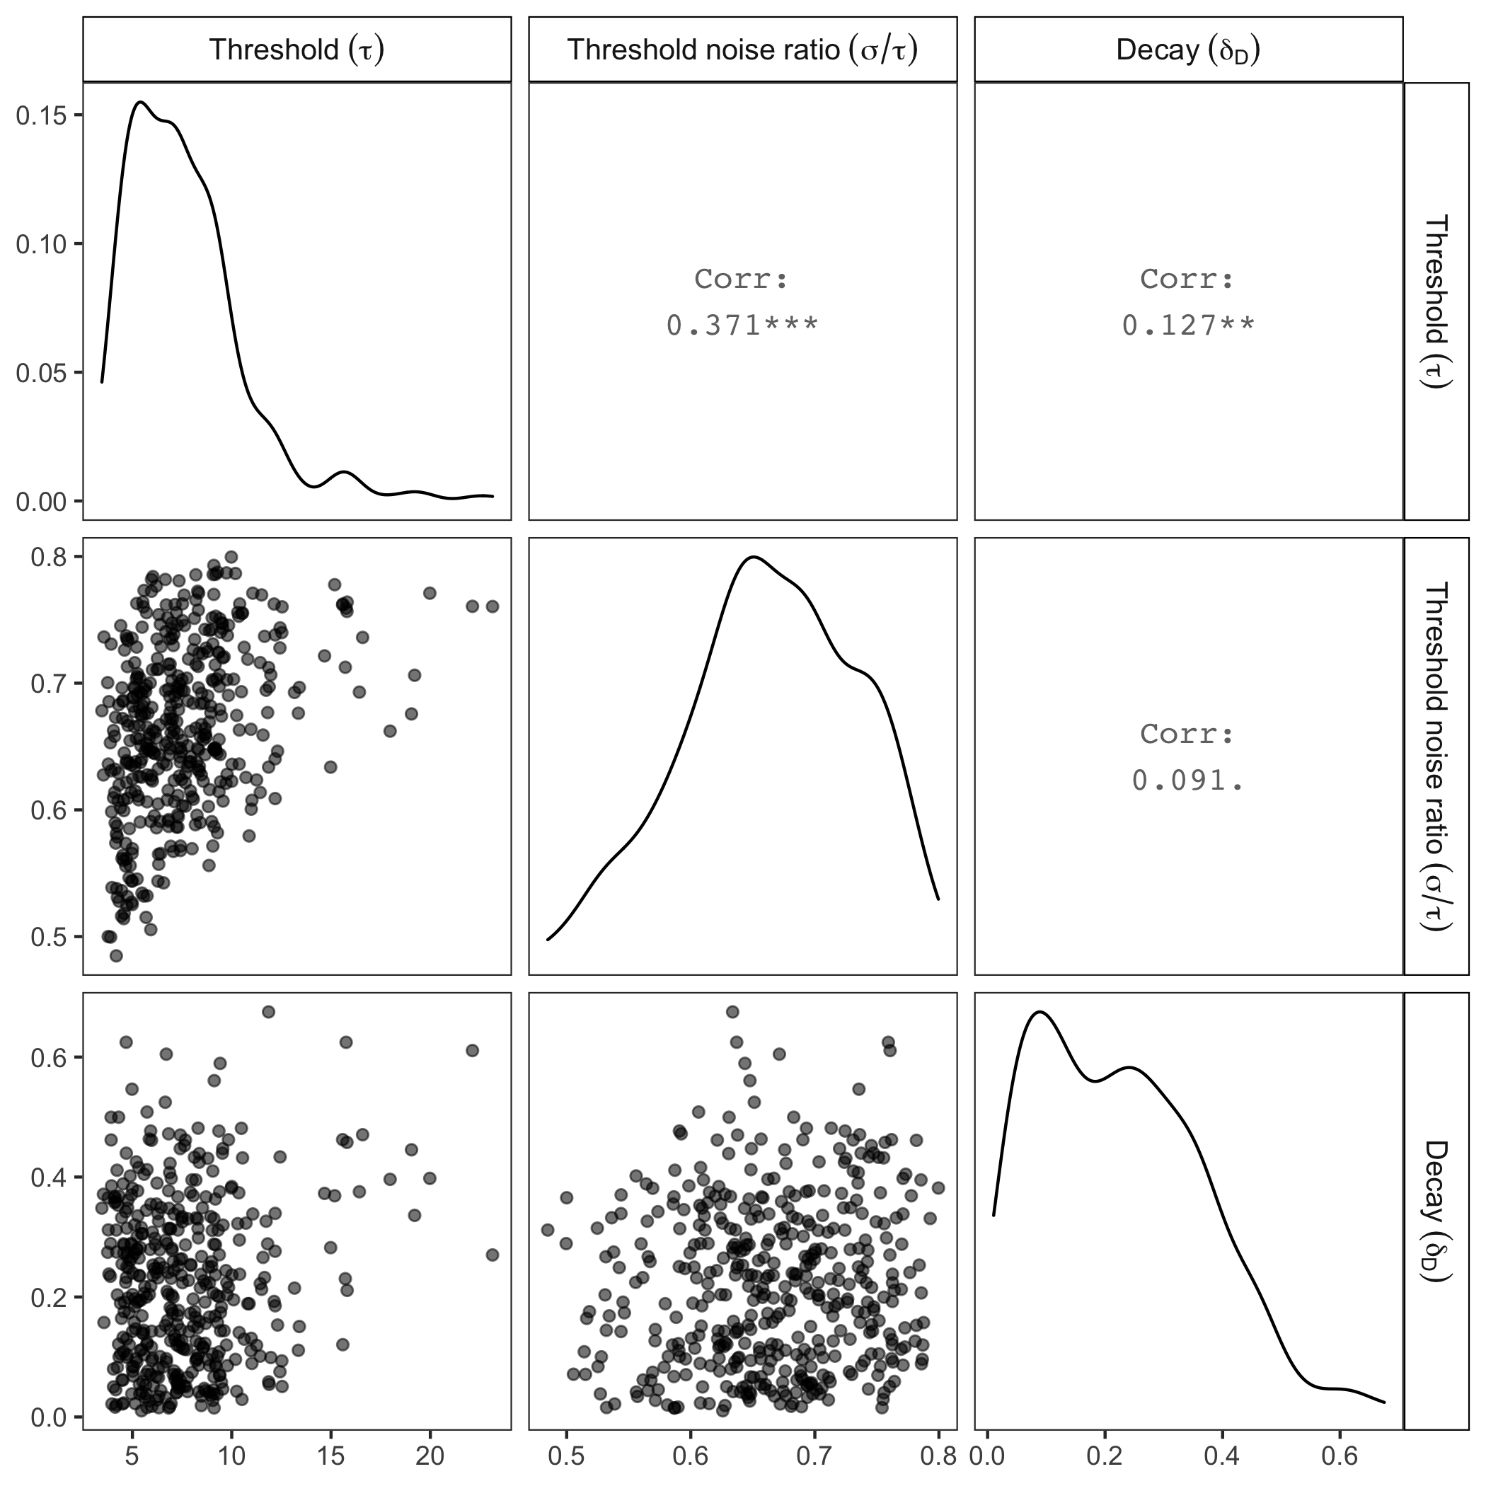

*Figure 12S.* Question-level parameter values for the hierarchical version of the full memory model (assuming flexible cluster resampling, semantic congruence and decision congruence with partial context decay). The dots represent posterior means, and the error bars indicate 95% credible intervals. The three rows are based on k-means clustering solution with *k* equals 2, 3, and 4 respectively.

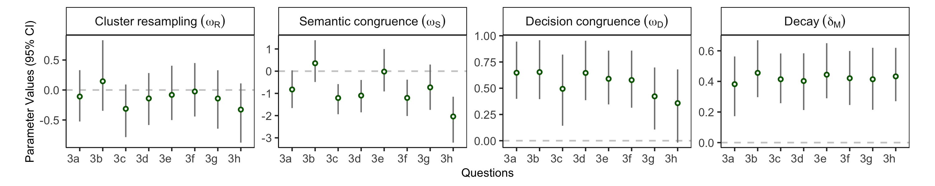

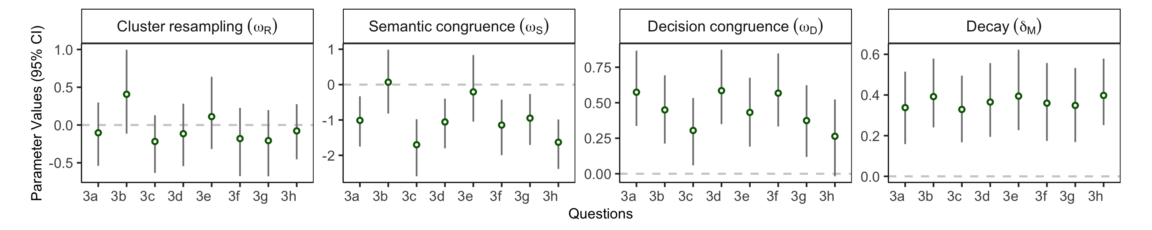

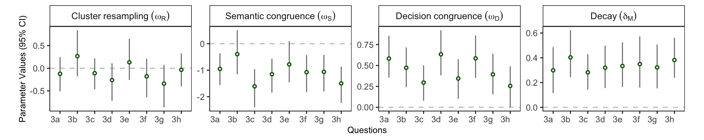

*Figure 13S*. Question-level parameter values for the hierarchical version of the primary decision model (absolute accumulation of binary inputs towards a threshold with partial context decay). The dots represent posterior means, and the error bars indicate 95% credible intervals.

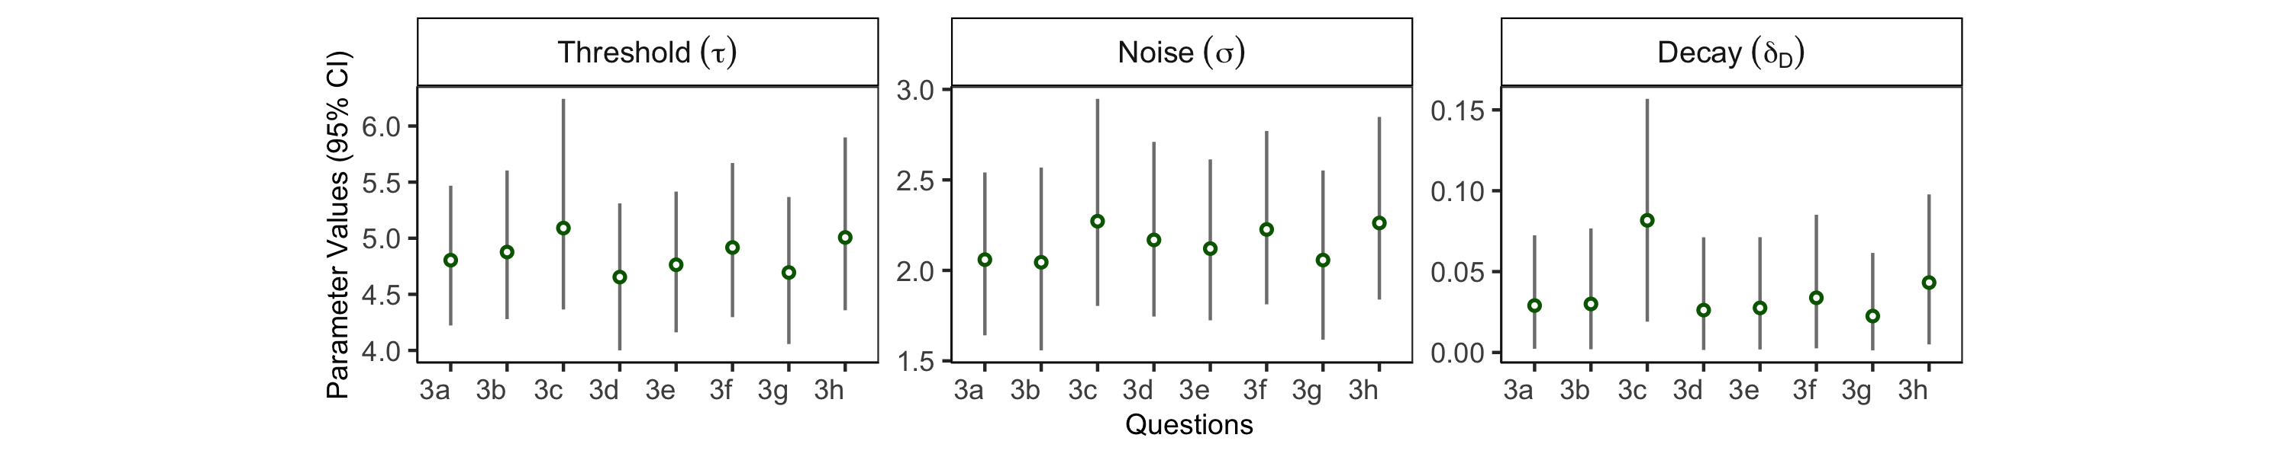

*Figure 14S.* Participant-level parameter values for the hierarchical version of the full memory model (assuming flexible cluster resampling, semantic congruence and decision congruence with partial context decay). The dots represent posterior means, and the error bars indicate 95% credible intervals. The three rows are based on k-means clustering solution with *k* equals 2, 3, and 4 respectively.

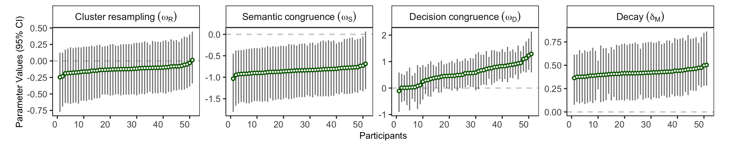

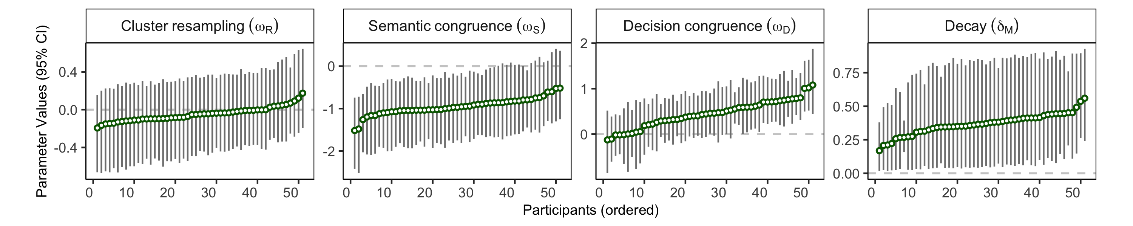

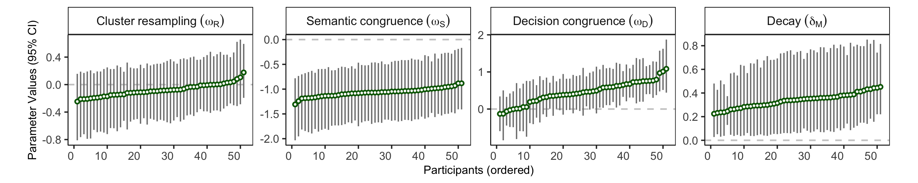

*Figure 15S*. Participant-level parameter values for the hierarchical version of the primary decision model (absolute accumulation of binary inputs towards a threshold with partial context decay). The dots represent posterior means, and the error bars indicate 95% credible intervals.

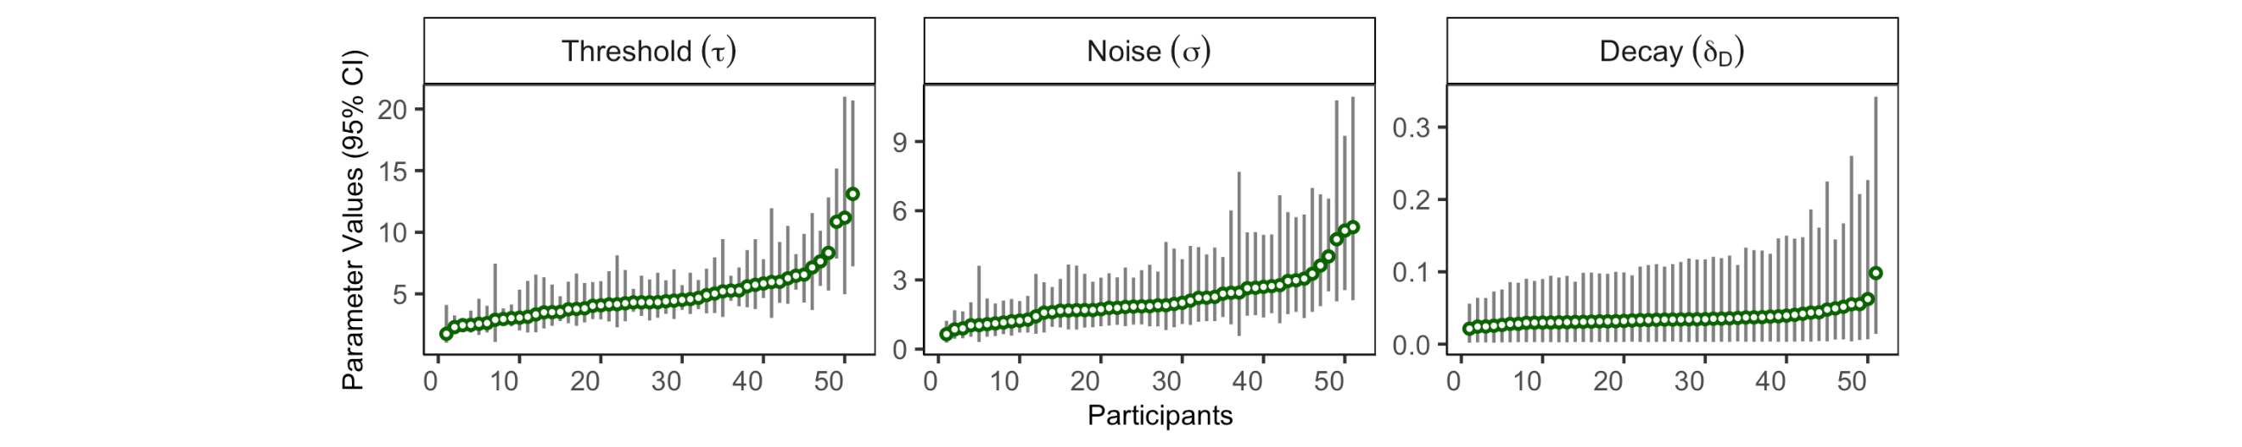

*Figure 16S*. Participant-level parameter values and behavioral metrics. All correlations are Spearman correlations. Averaged number of thoughts listed across questions correlate with decision threshold ($τ$) and threshold-noise ratio ($σ/τ$) in the decision model. Individual differences in sampling congruence are strongly correlated with the sampling parameters ($ω_{D},ω_{S}$) in the memory model.

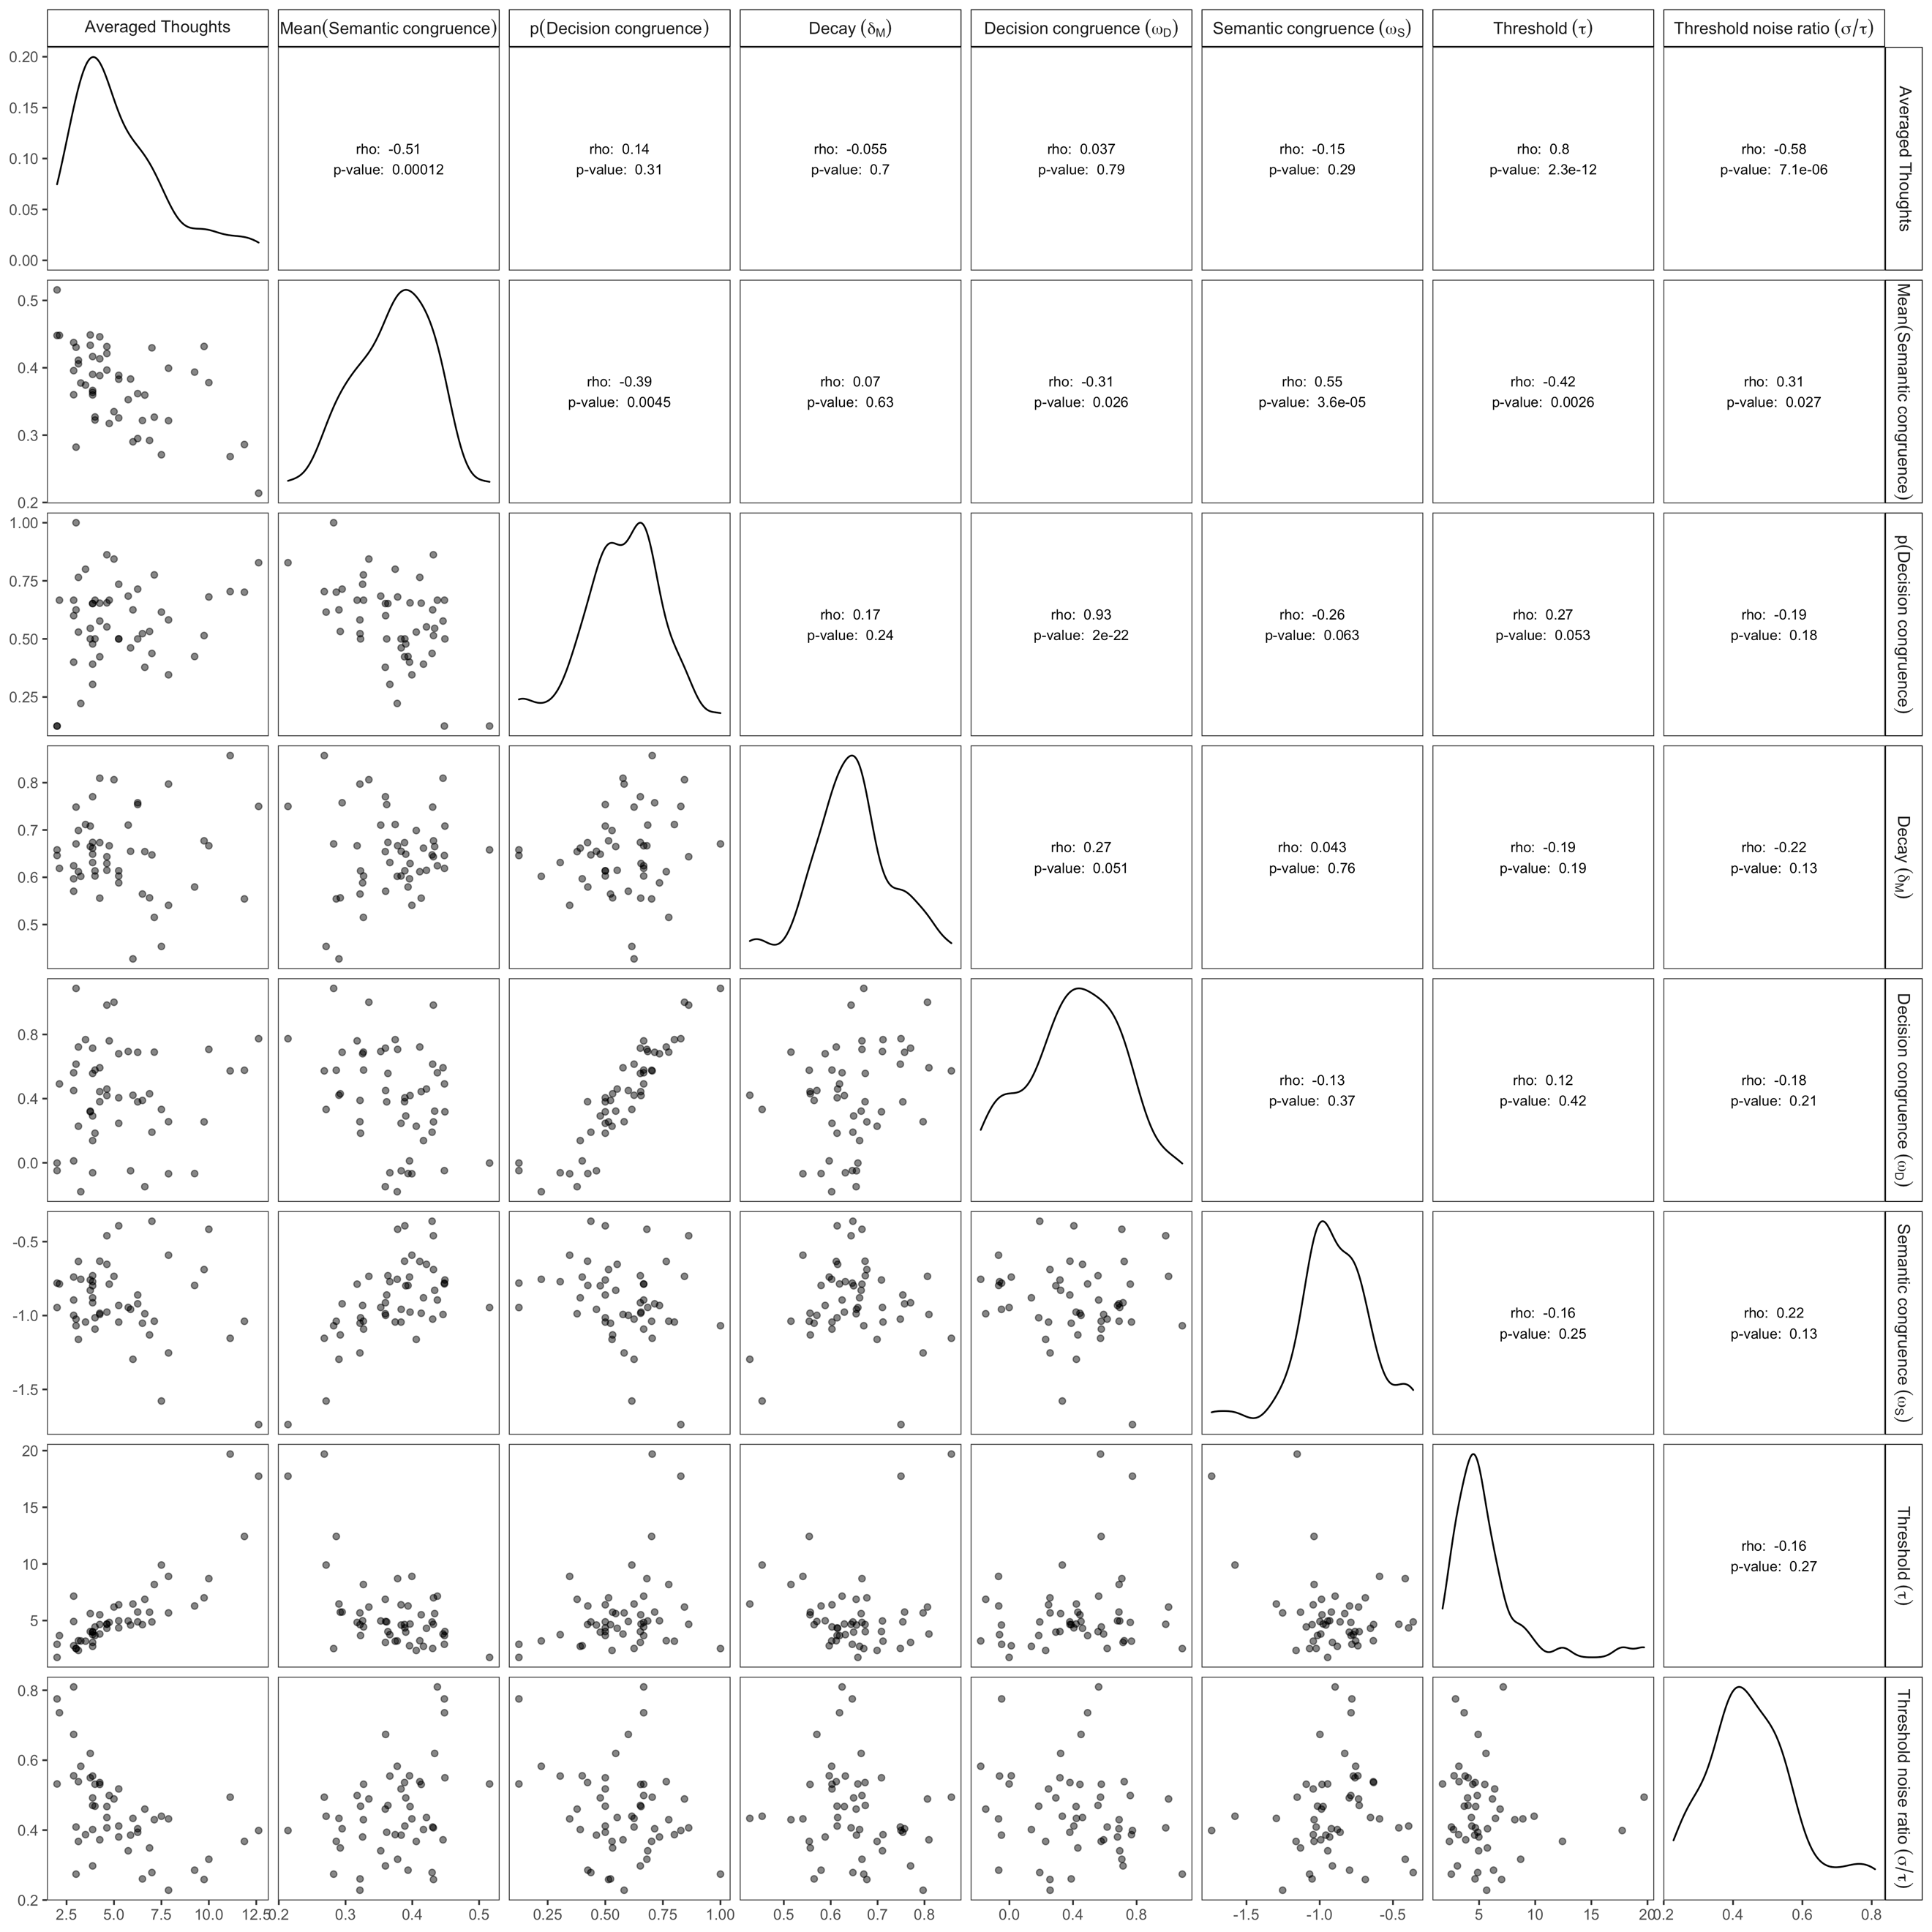

*Figure 17S.* Difference in probability of choosing the first option for condition 1 vs. 2, in Experiments 2a-2b. Posterior samples of parameters from Experiments 2a and 2b are used to simulate data. The three panels are based on k-means clustering solution with *k* = 2, 3, and 4 respectively. Error bars indicate standard errors.

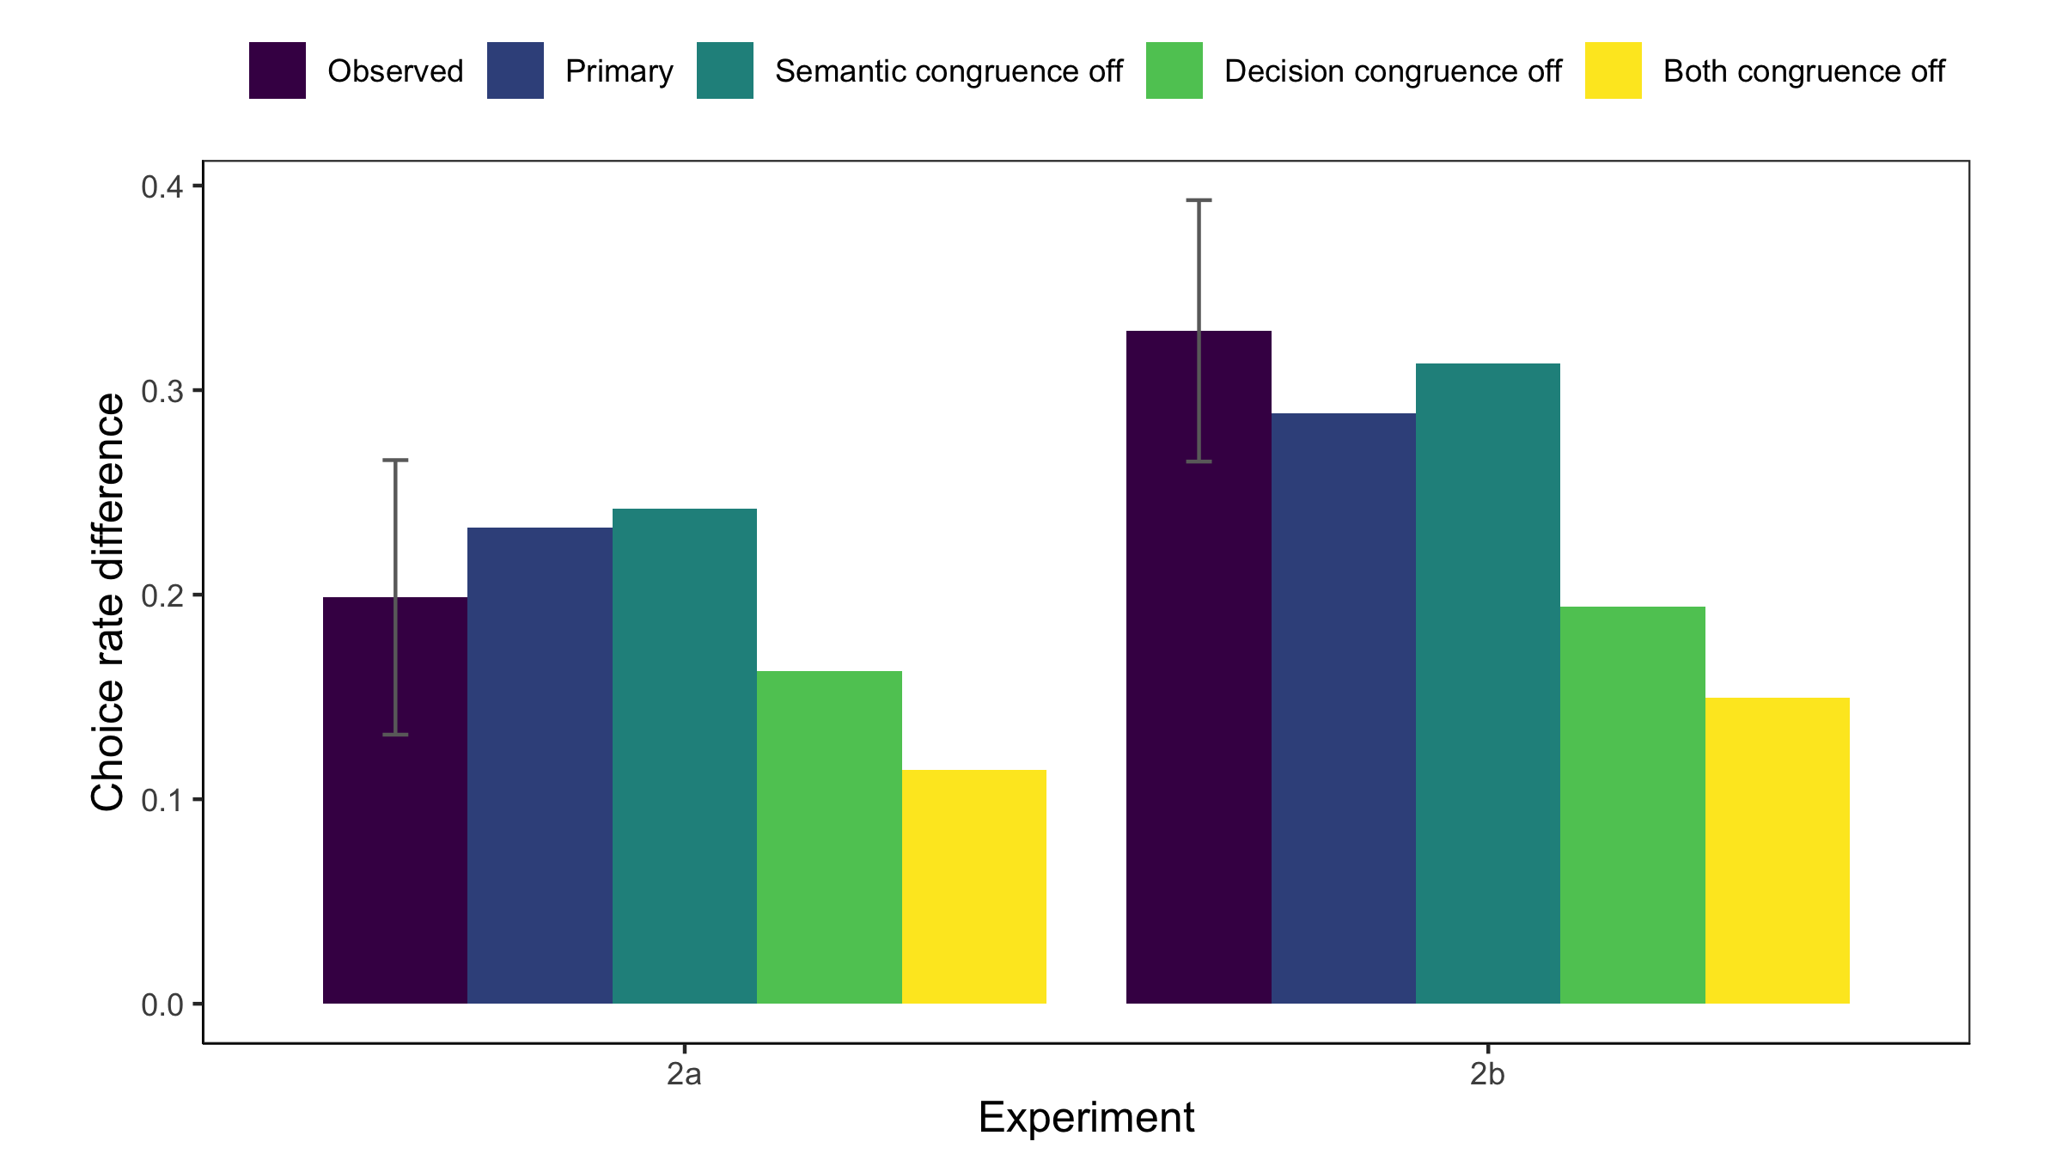

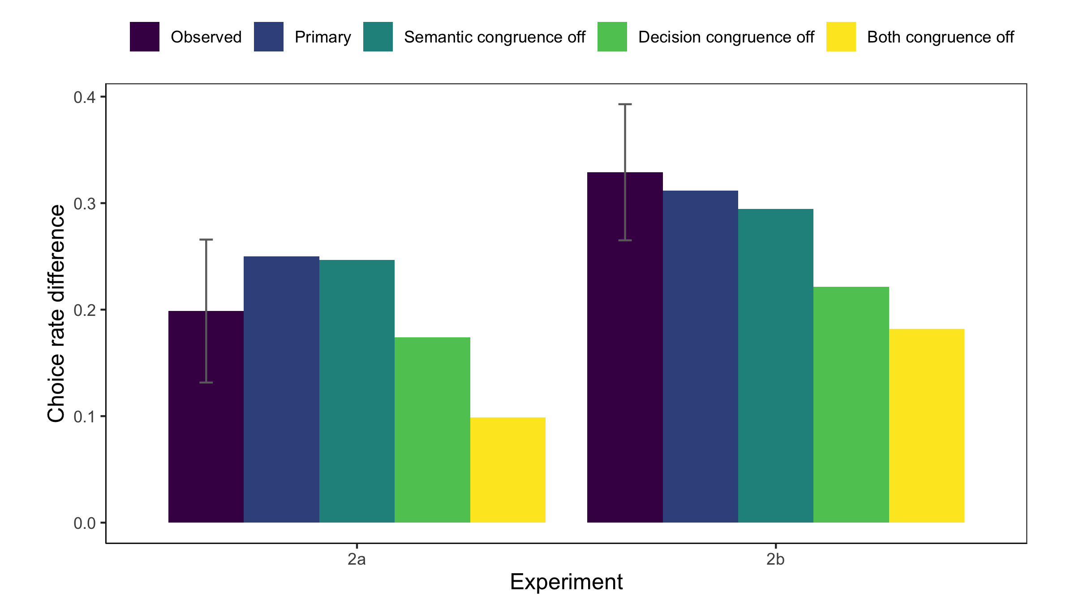

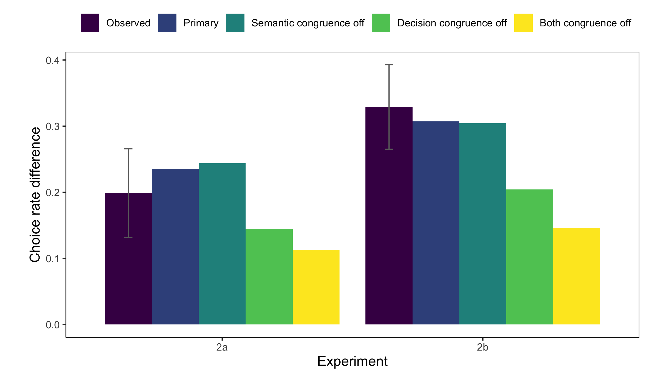

*Figure 18S.* Distributions of thought clusters supporting different options in Experiments 2a and 2b, *after excluding the first thought*. Posterior samples of parameters from Experiments 2a and 2b are used to simulate data. The three panels are based on k-means clustering solution with *k* = 2, 3, and 4 respectively.

